Tour ID: 237385  
Tour Name: Wonders of Iceland

Tour destinations: ['Reykjavik', 'Thingvellir National Park', 'Selfoss', 'Hvolsvollur', 'Vik', 'Jokulsarlon', 'Akureyri', 'Reykholt', 'Blue Lagoon']

Tour destinations images:

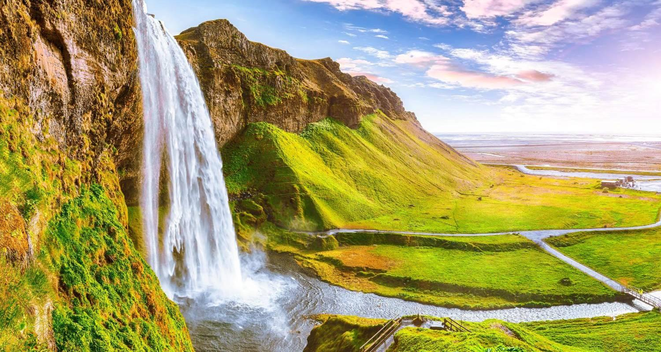

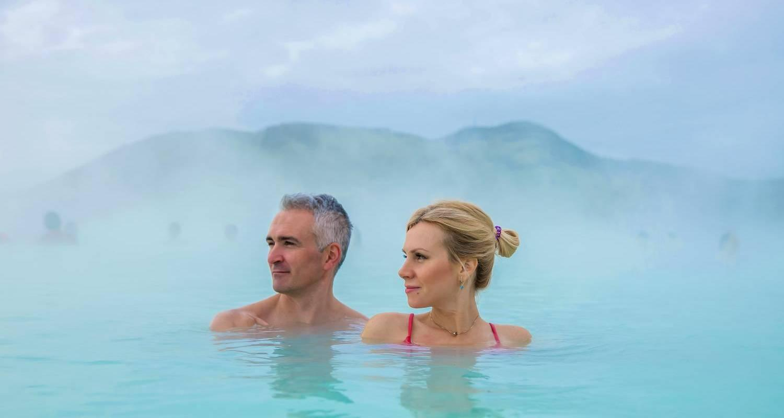

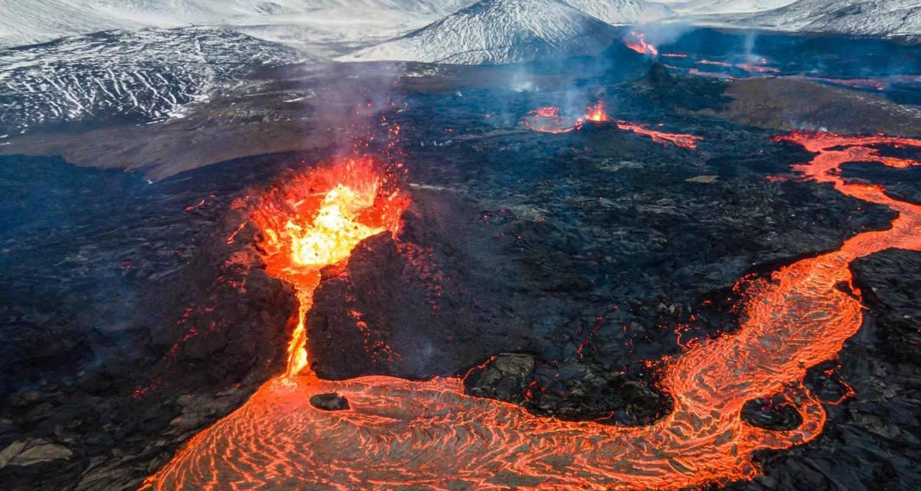

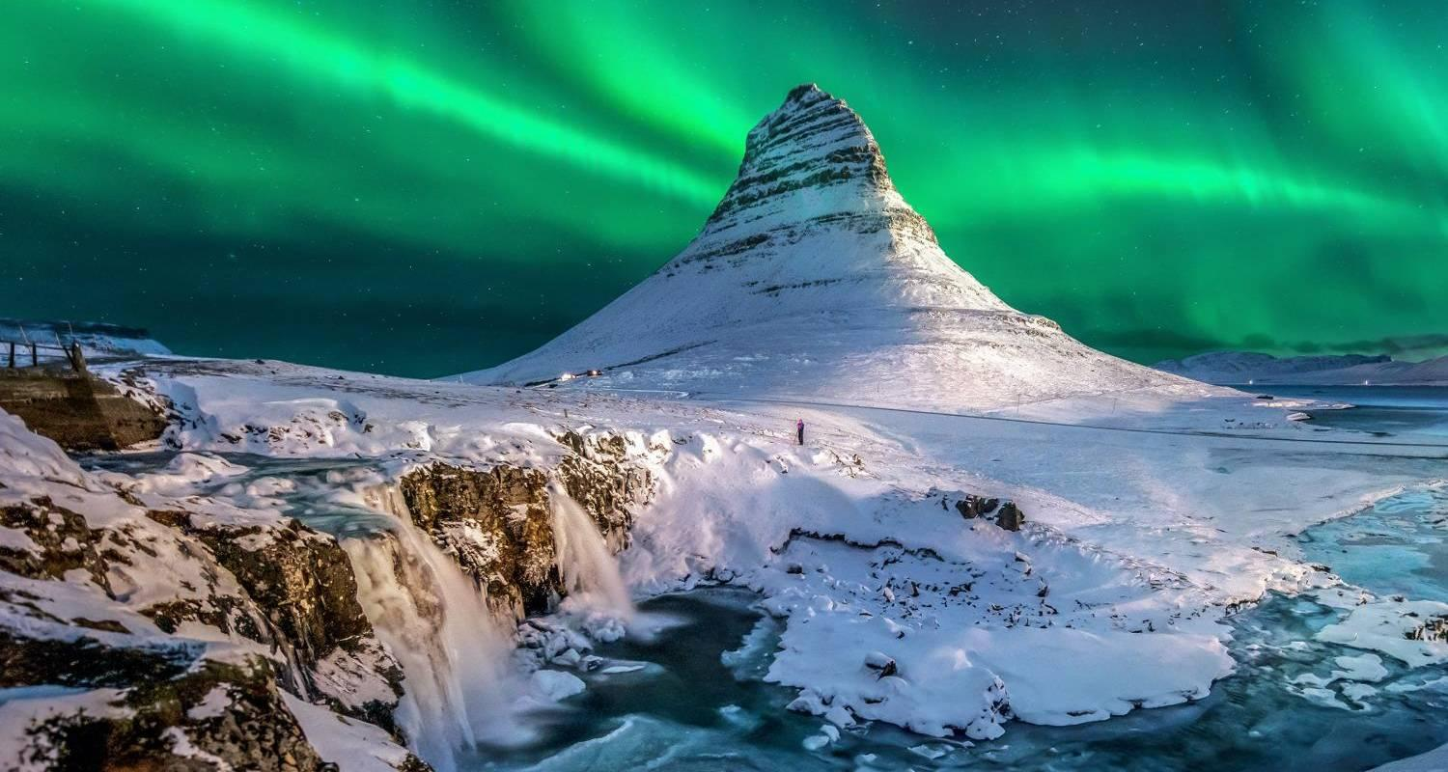

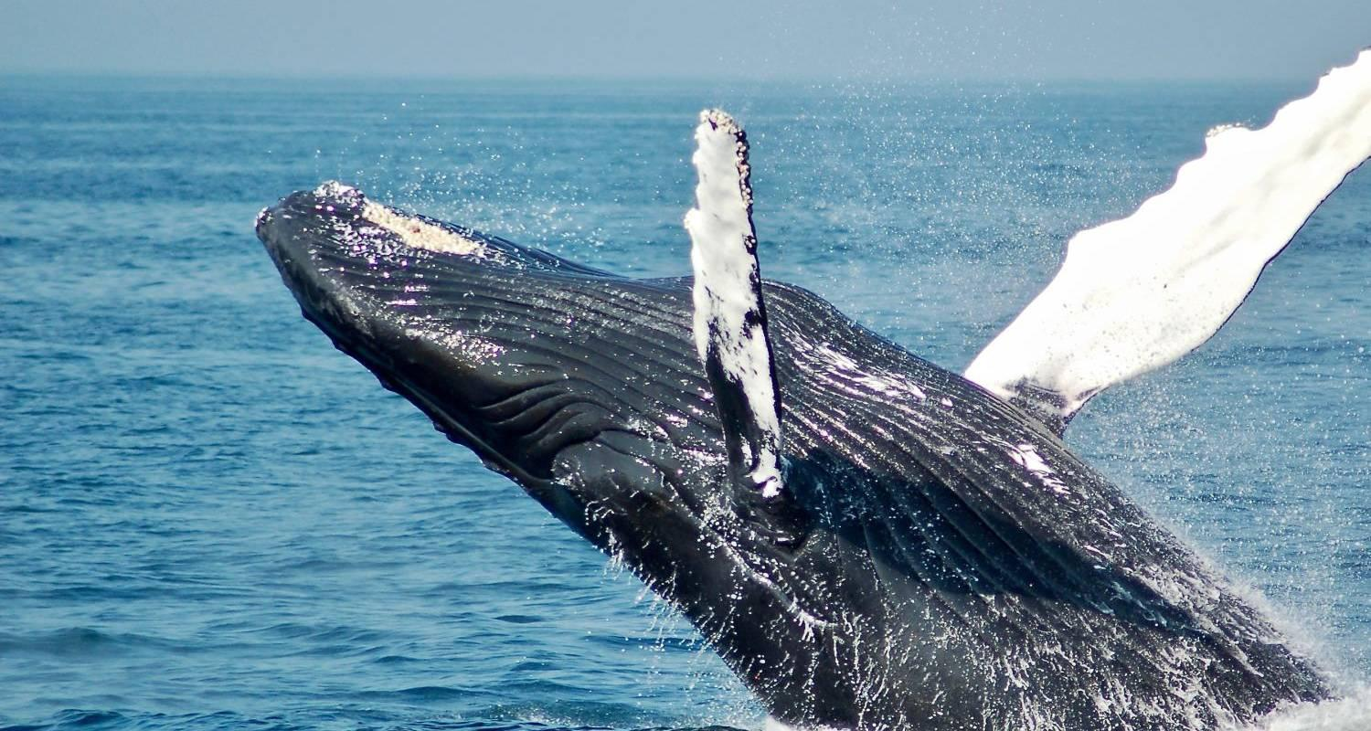

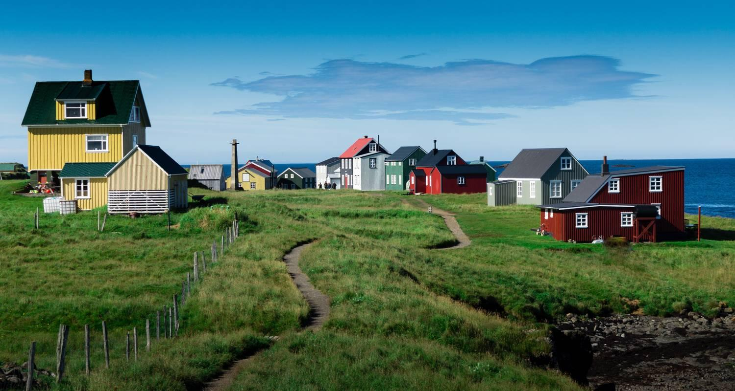

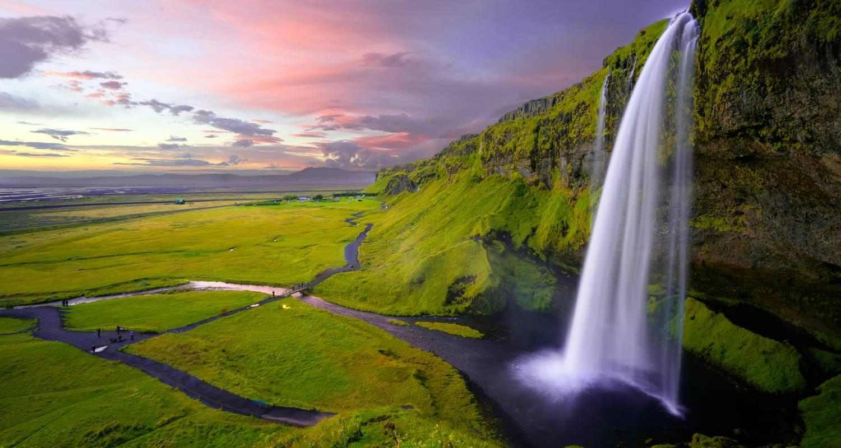

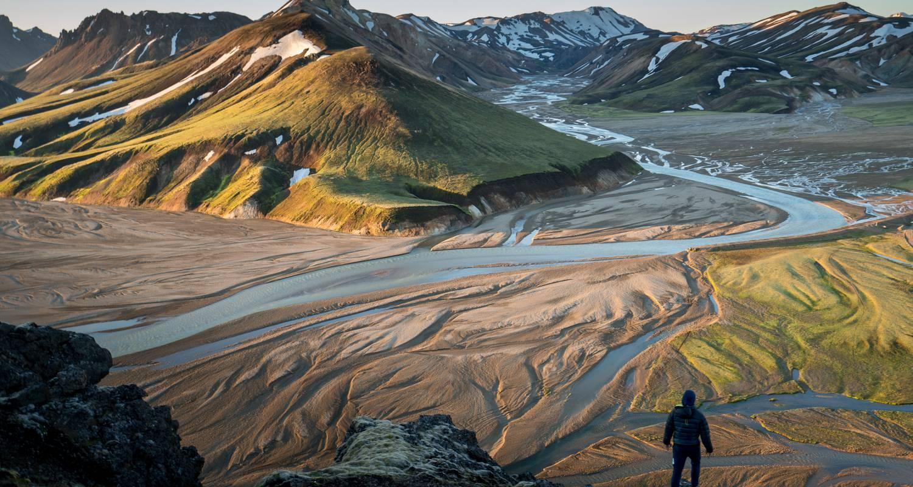

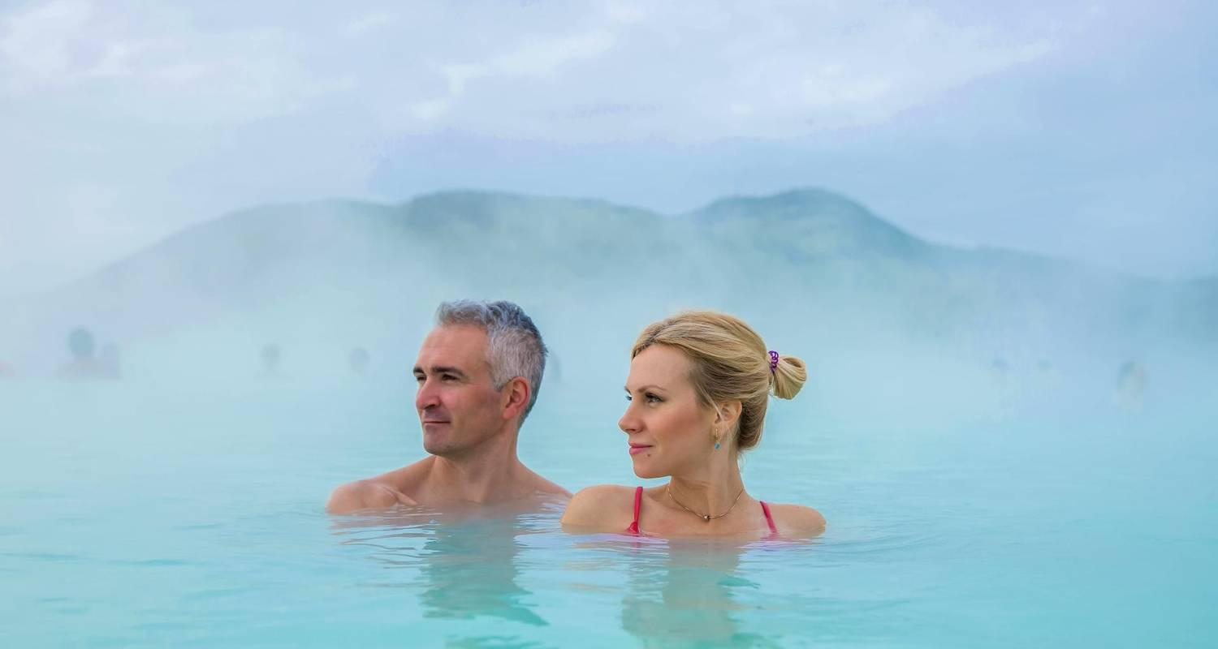

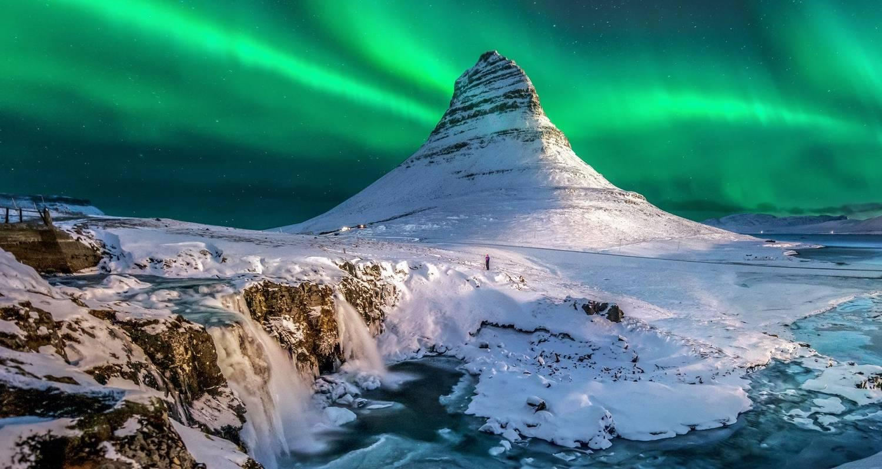

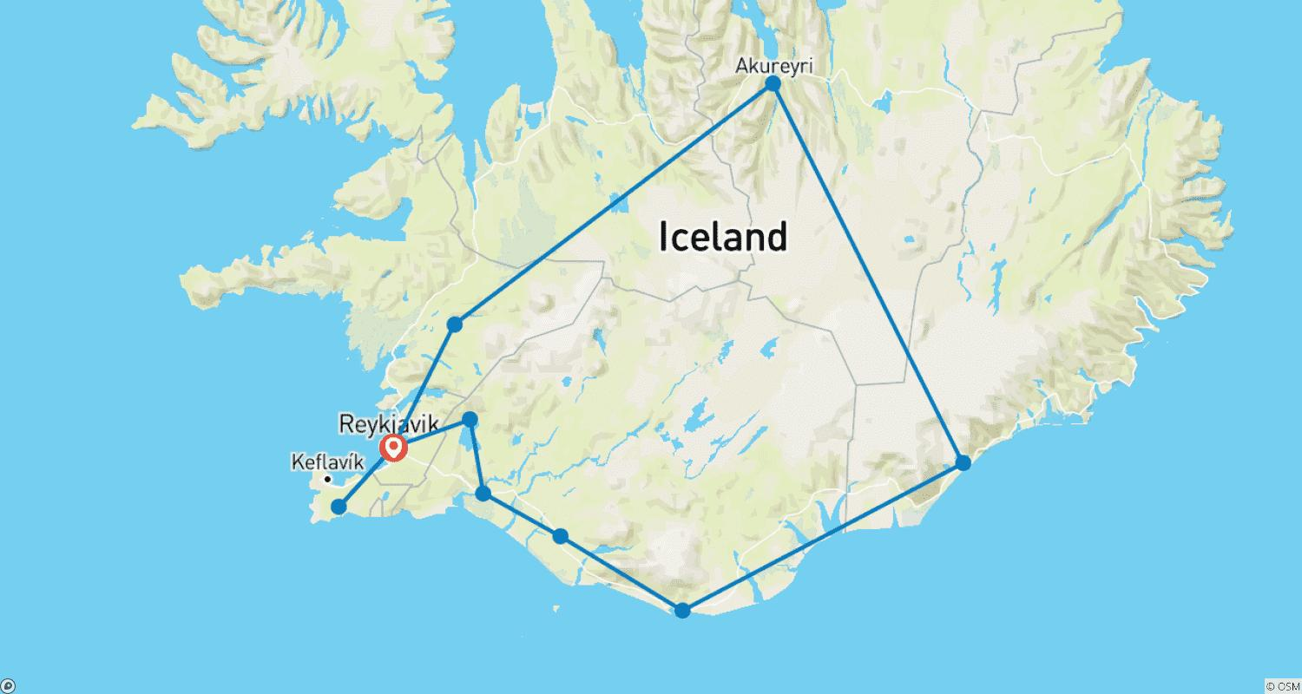

Tour ID: 237422  
Tour Name: Golden Circle & Friðheimar Sustainable Farm Day Tour - Private Tour

Tour destinations: ['Reykjavik', 'Thingvellir National Park', 'Geysir', 'Gullfoss', 'Fludir']

Tour destinations images:

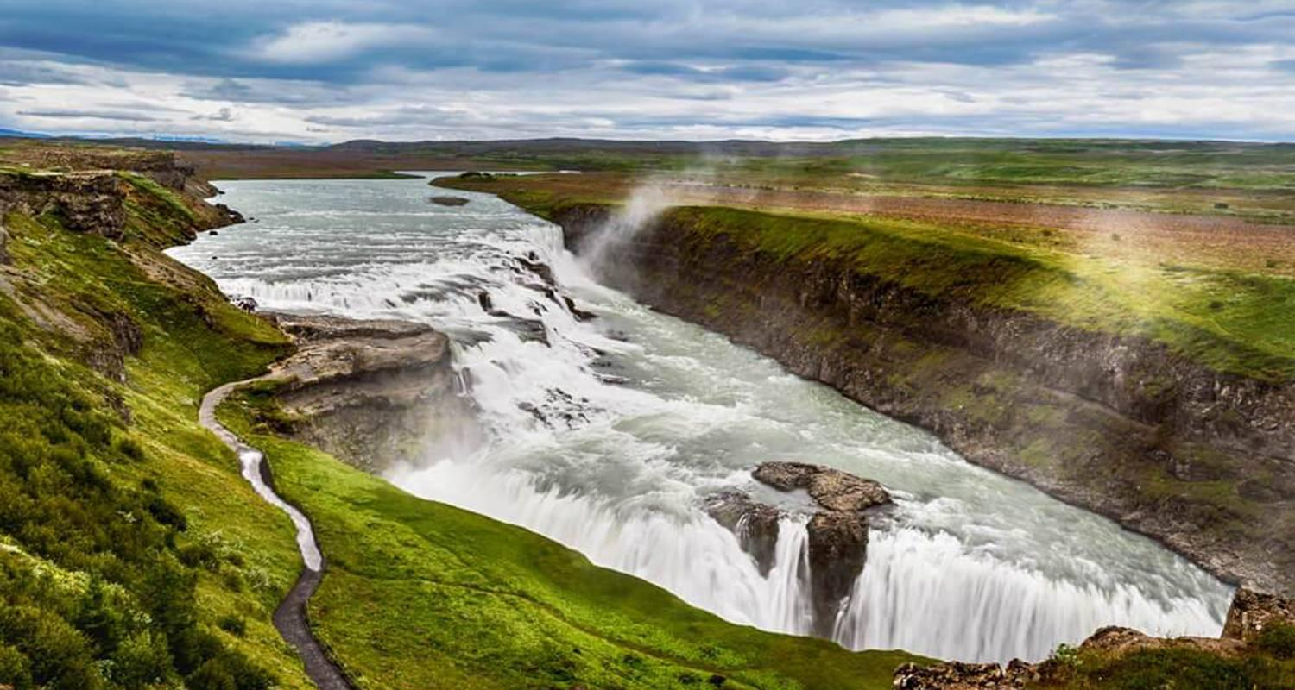

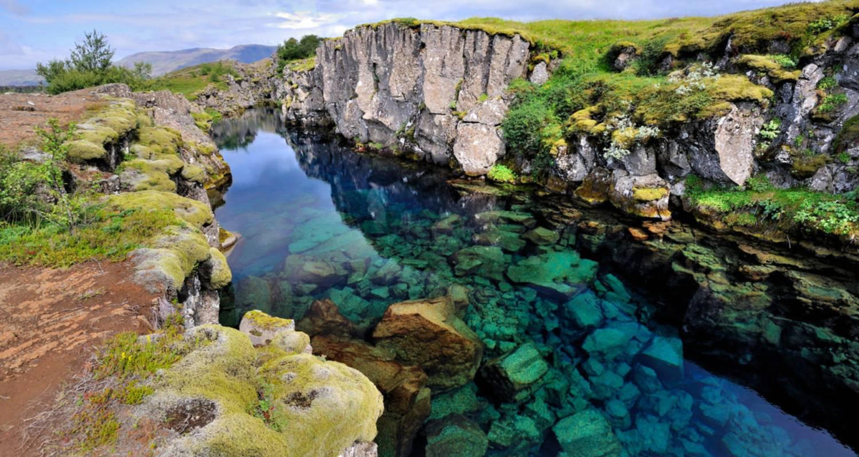

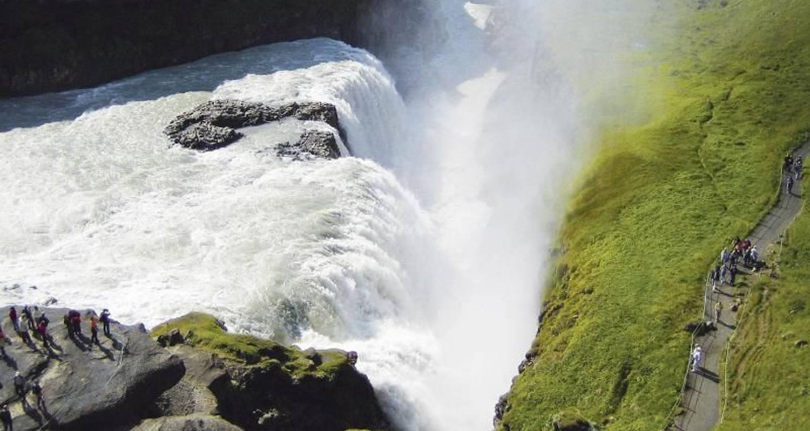

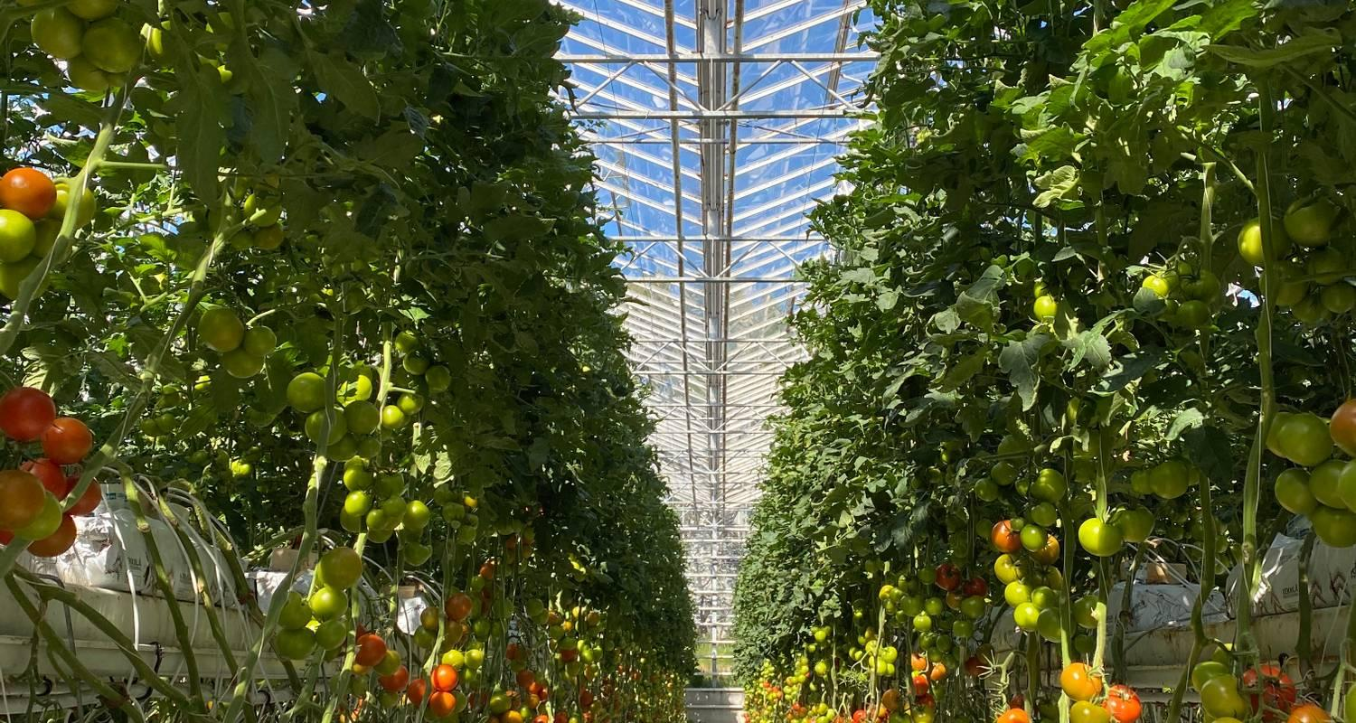

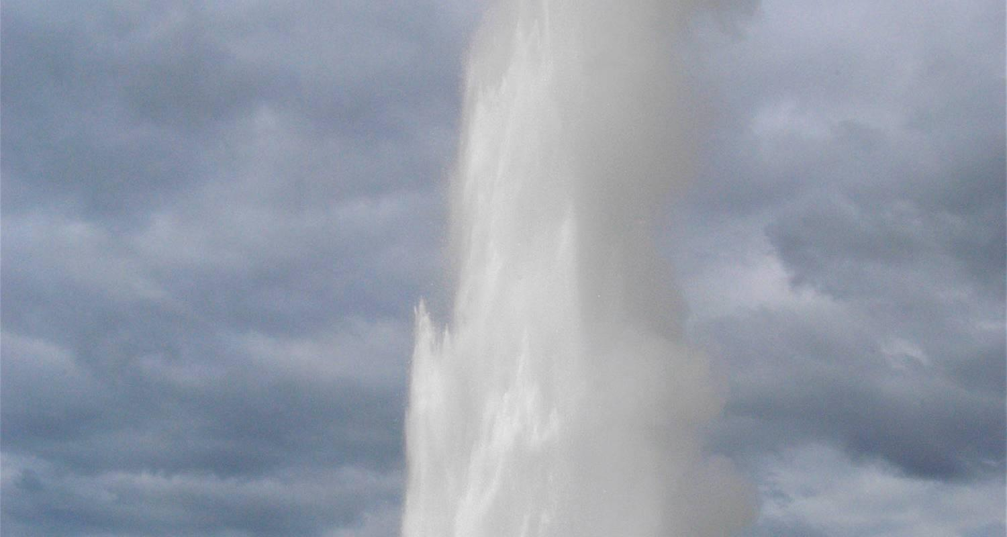

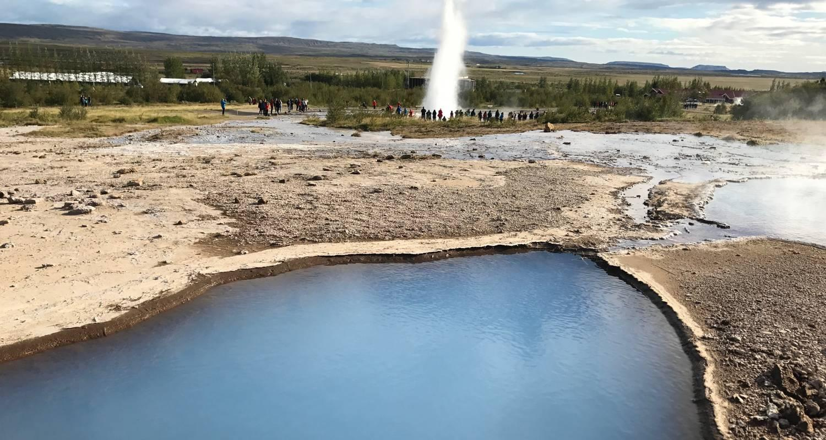

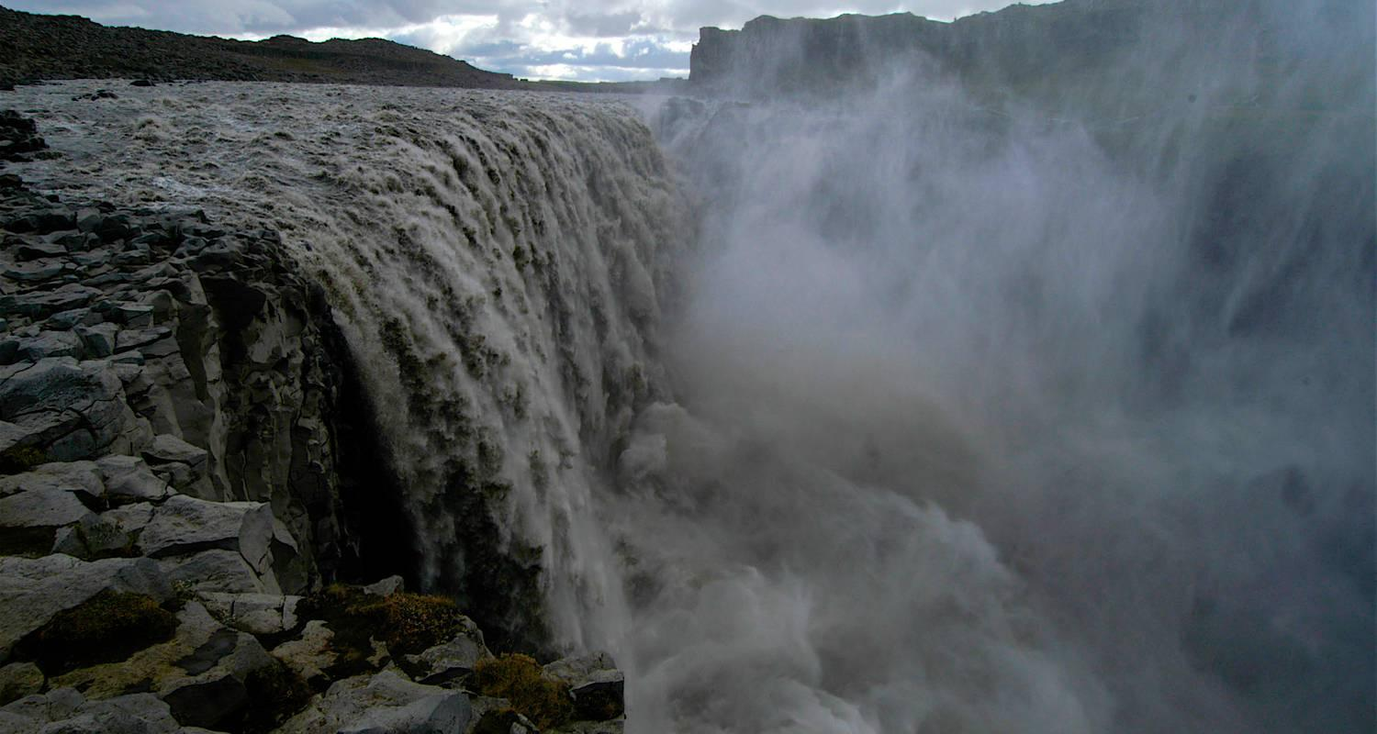

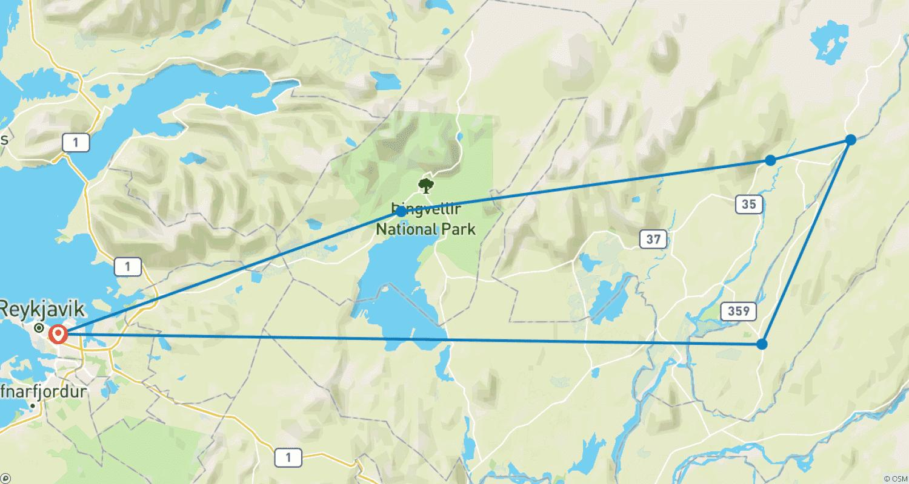

Tour ID: 237423  
Tour Name: 6 Day Family Winter Tour - Private Tour

Tour destinations: ['Keflavik', 'Reykjavik', 'Thingvellir National Park', 'Gullfoss', 'Geysir', 'Secret Lagoon', 'Skogafoss', 'Solheimajokull', 'Reynisdrangar Cliffs', 'Reynisfjara', 'Vik', 'Blue Lagoon']

Tour destinations images:

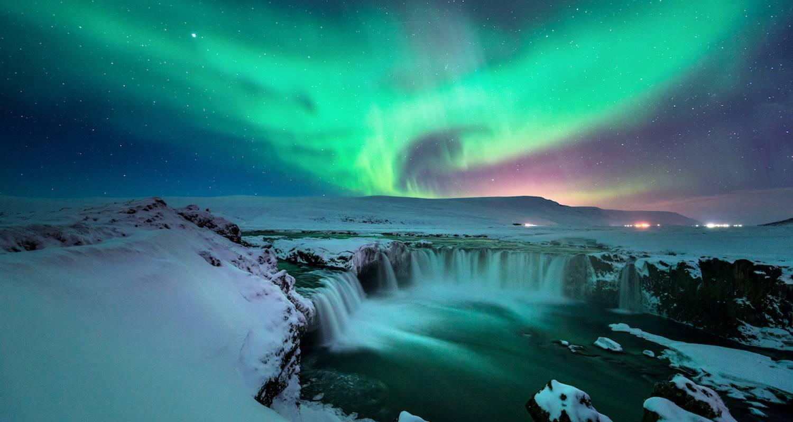

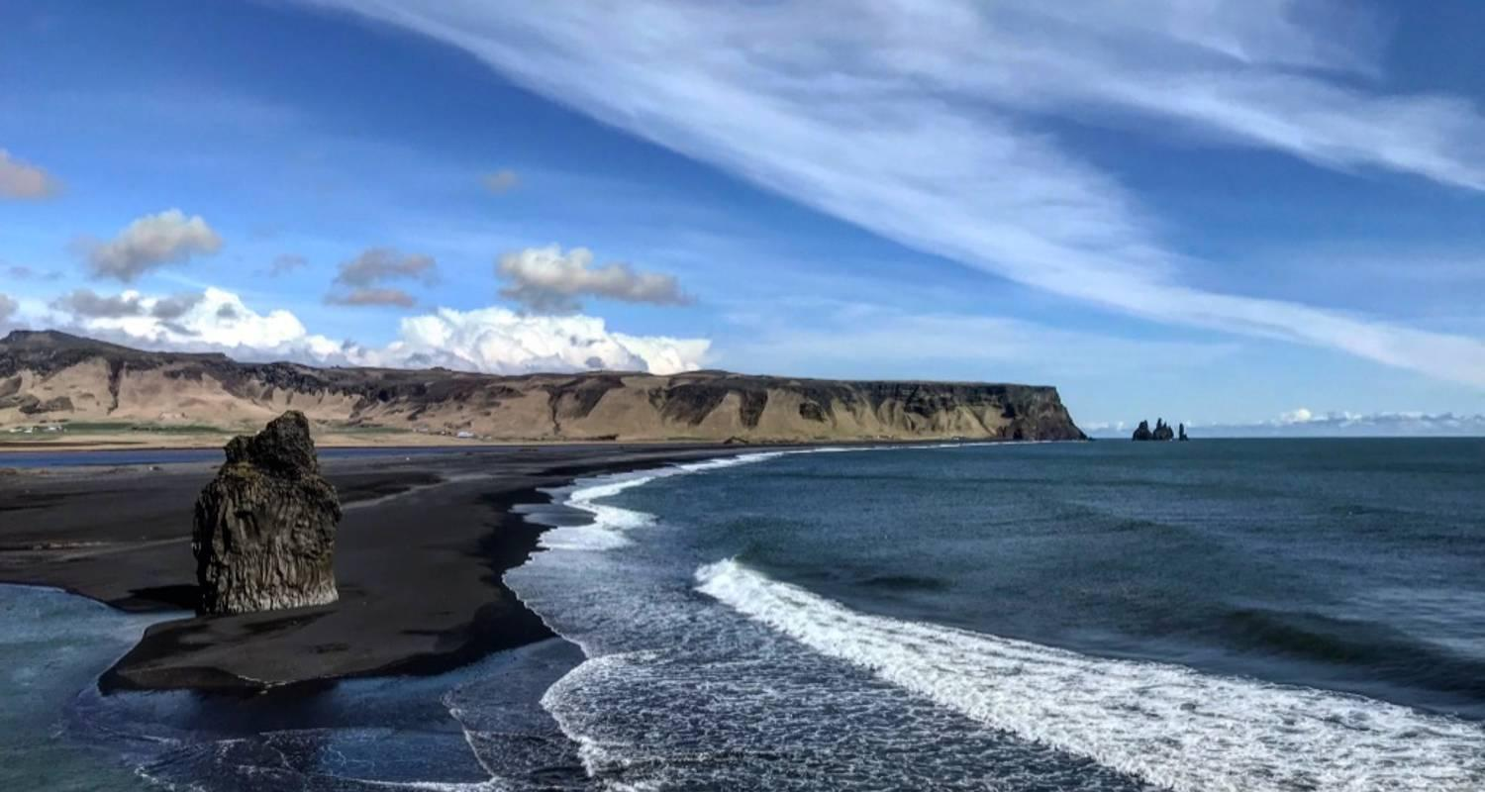

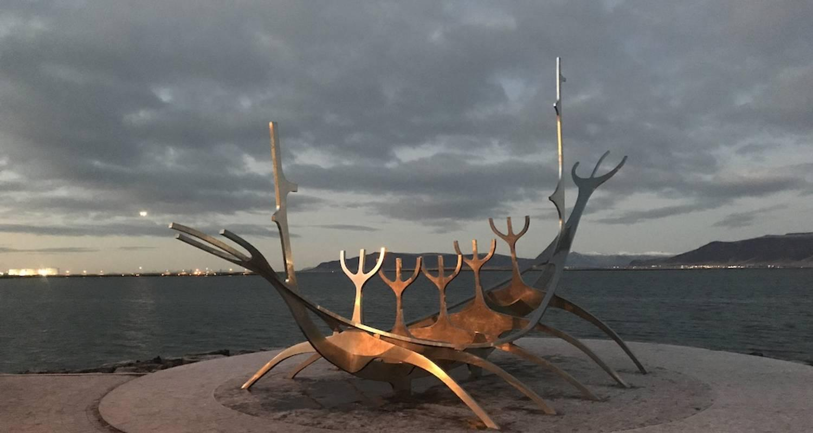

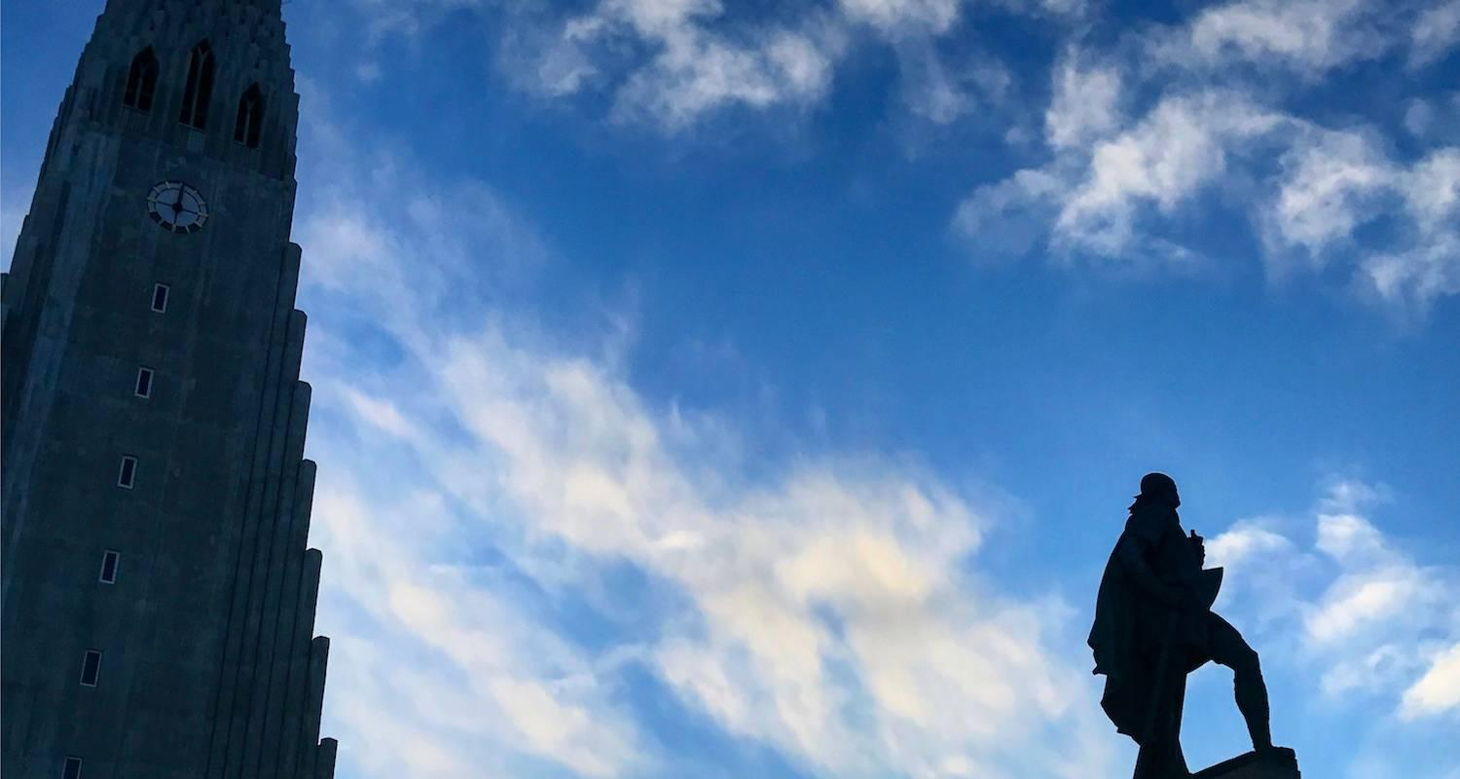

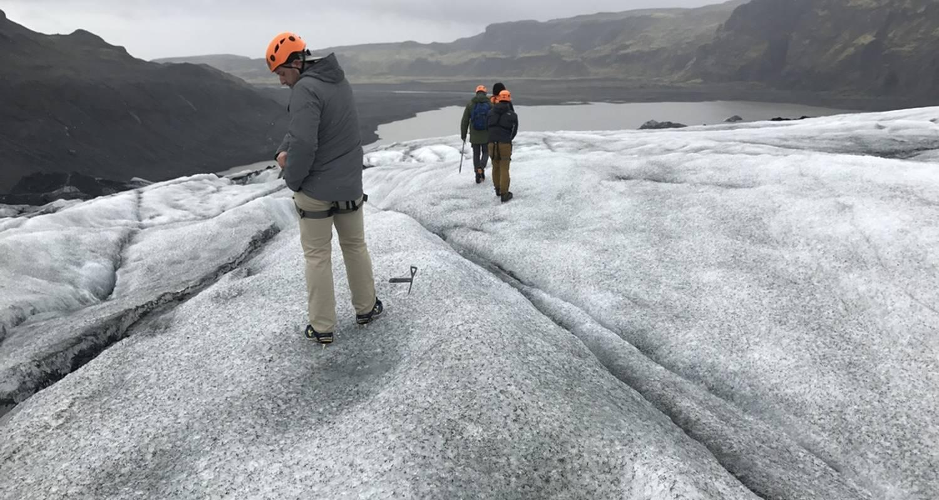

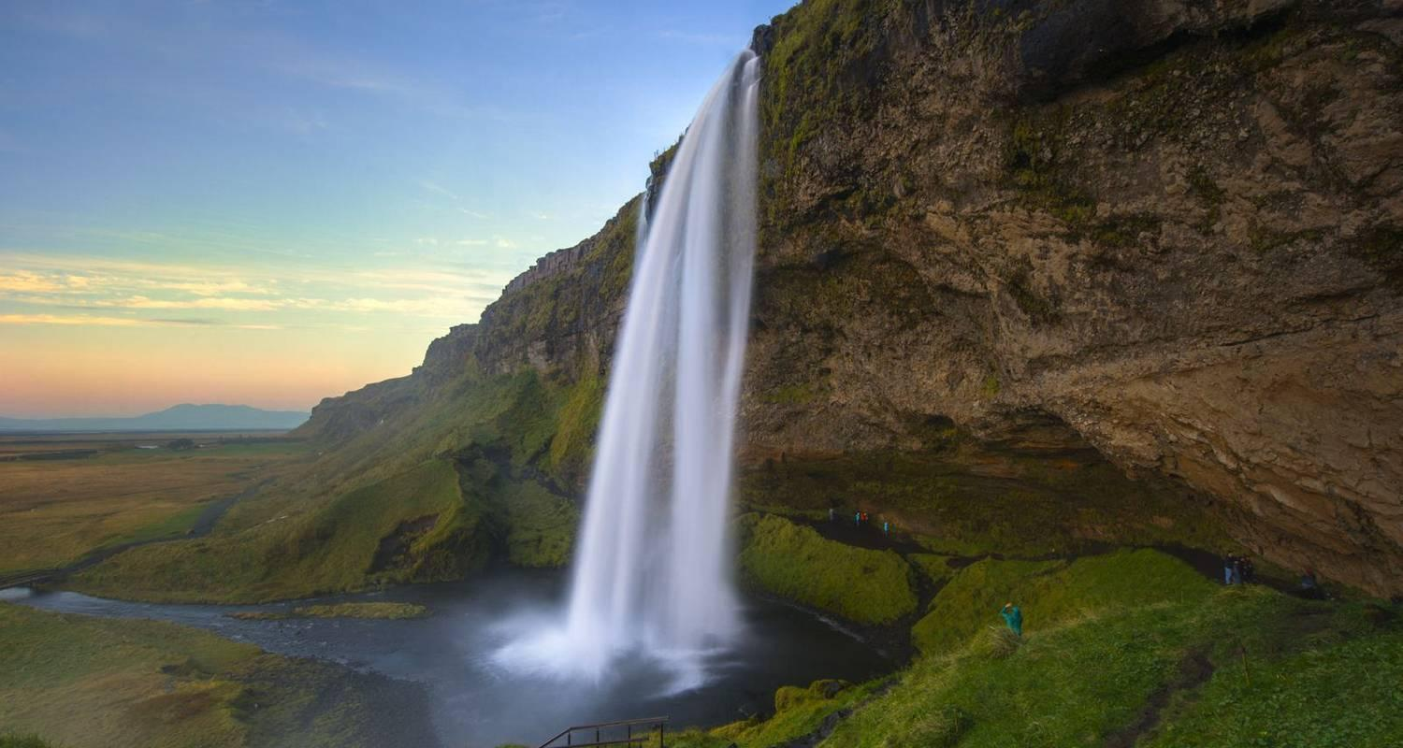

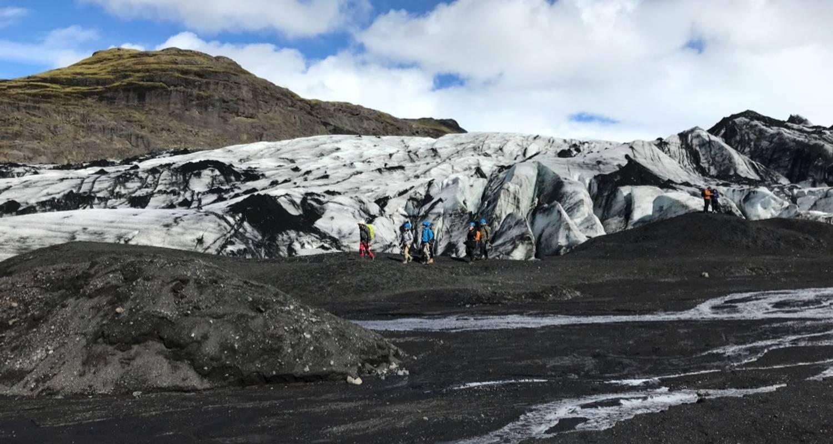

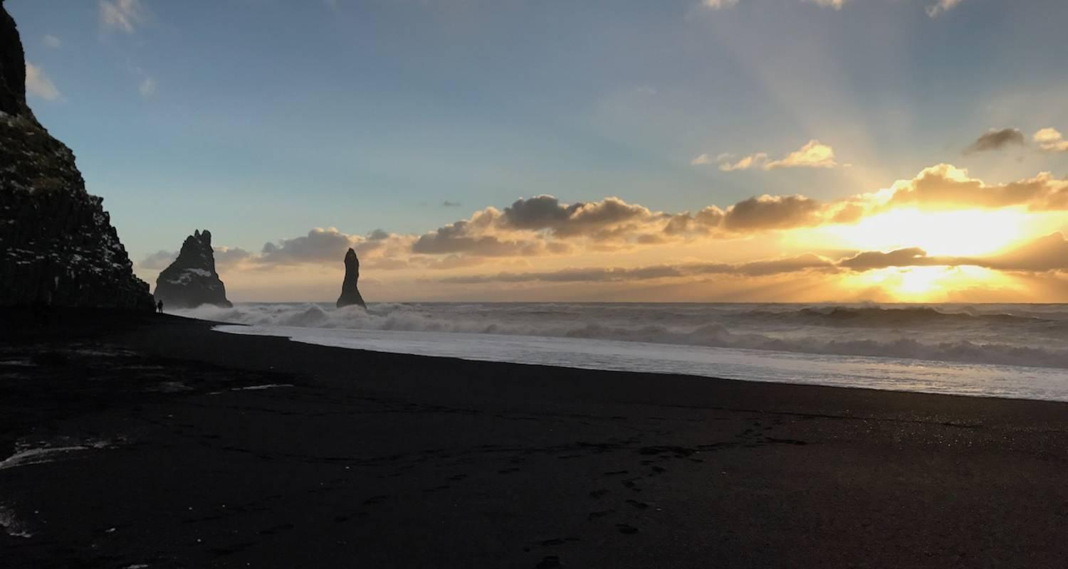

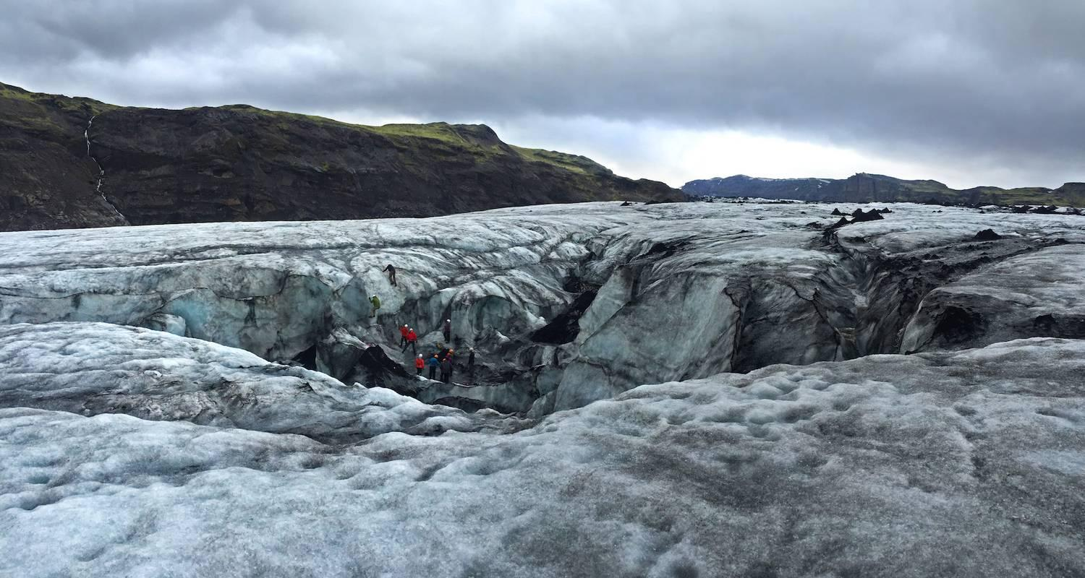

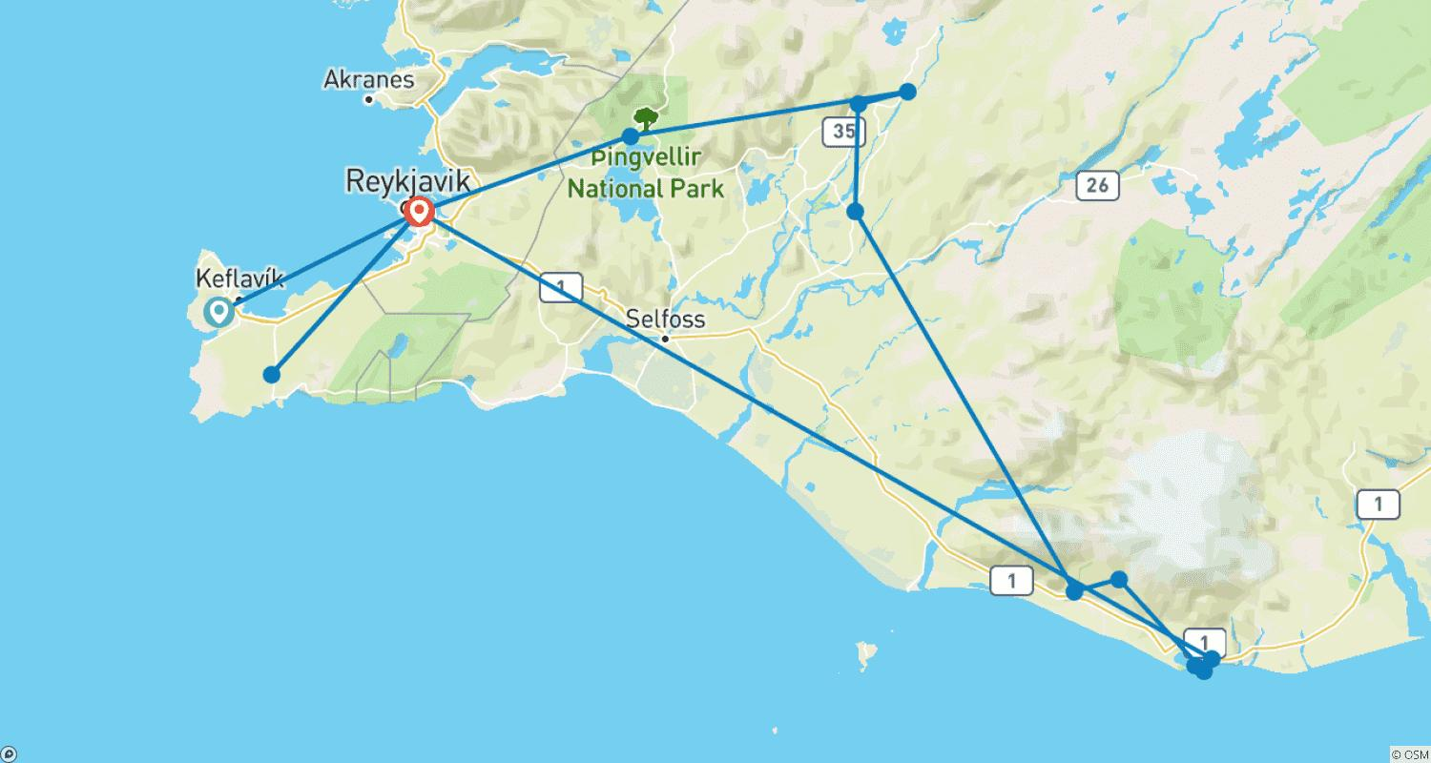

Tour ID: 237424  
Tour Name: 6 Day Family Summer Tour - Private Tour

Tour destinations: ['Keflavik', 'Reykjavik', 'Blue Lagoon', 'Thingvellir National Park', 'Gullfoss', 'Geysir', 'Secret Lagoon', 'Seljaland', 'Skogafoss', 'Solheimajokull', 'Reynisdrangar Cliffs', 'Reynisfjara', 'Vik']

Tour destinations images:



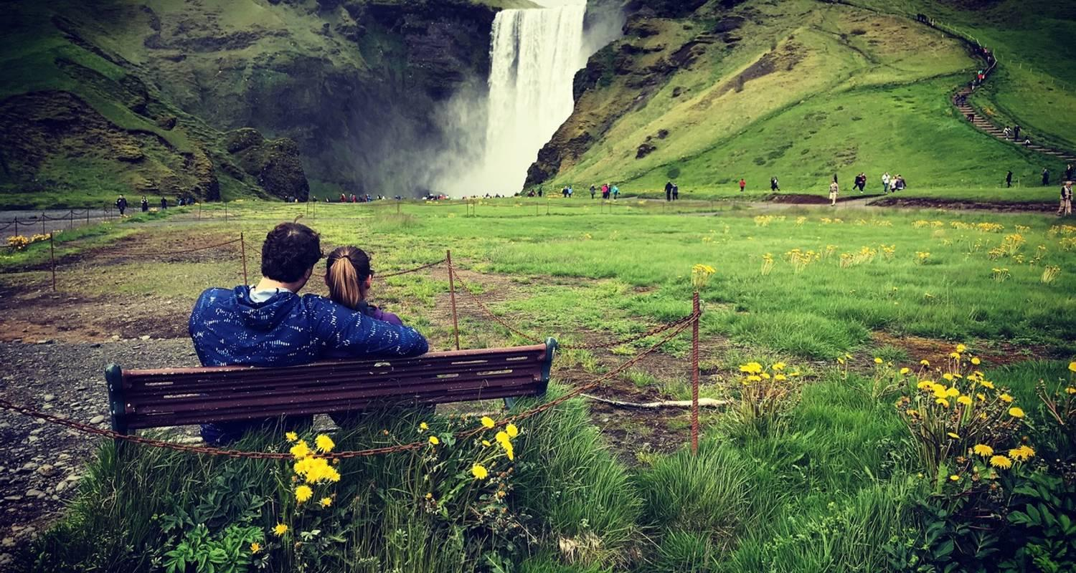

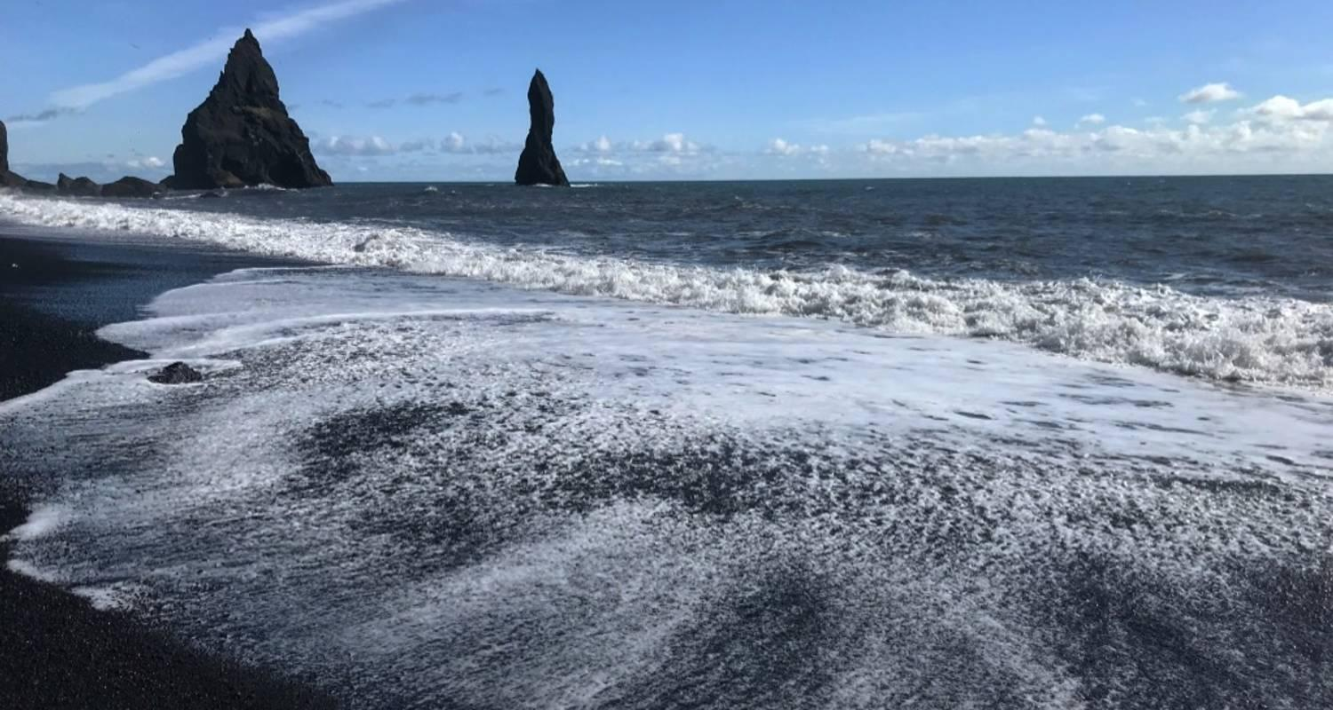









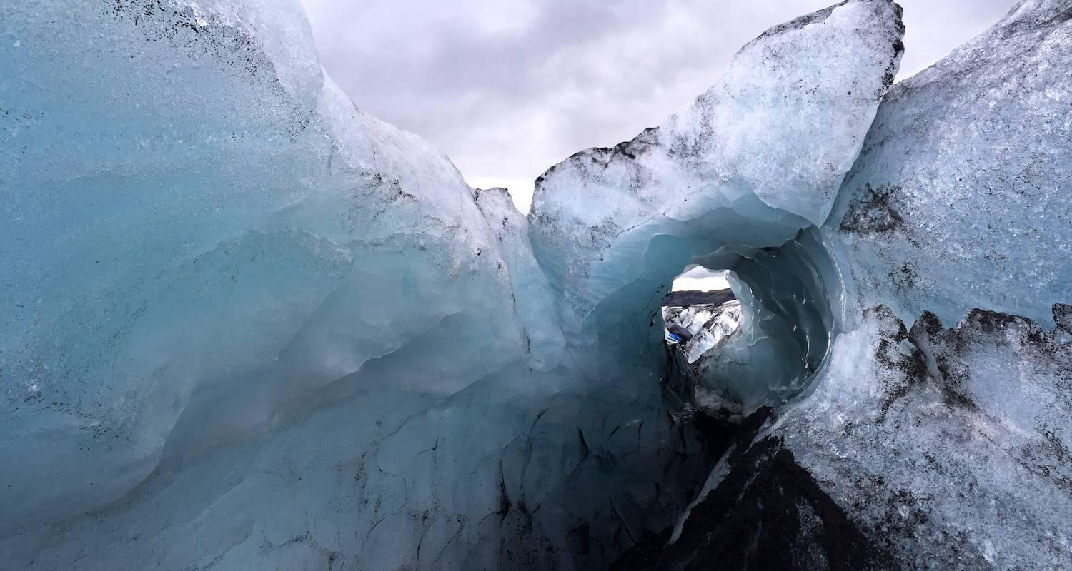

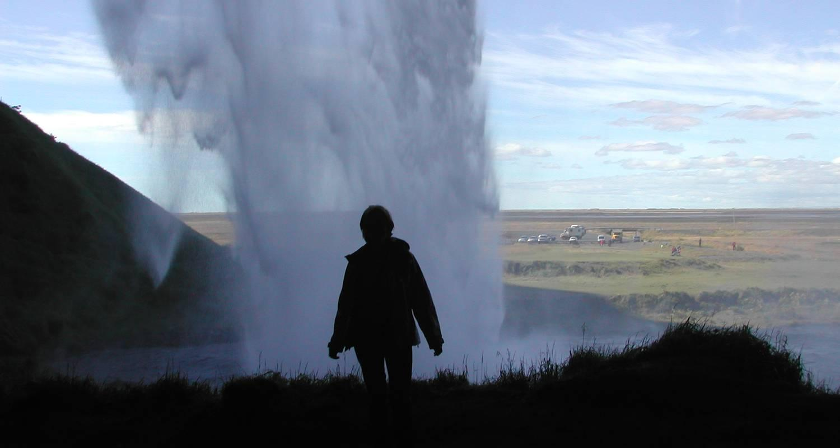



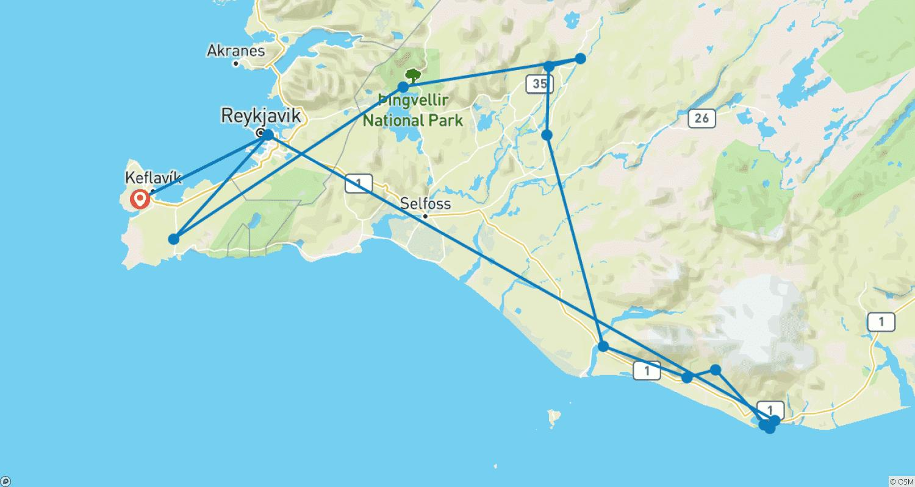

Tour ID: 237605  
Tour Name: 4-Day Þórsmörk Glacier Valley Hiking Adventure

Tour destinations: ['Reykjavik', 'Thorsmork', 'Thorsmork Nature Reserve', 'Fimmvorduhals Volcano']

Tour destinations images:

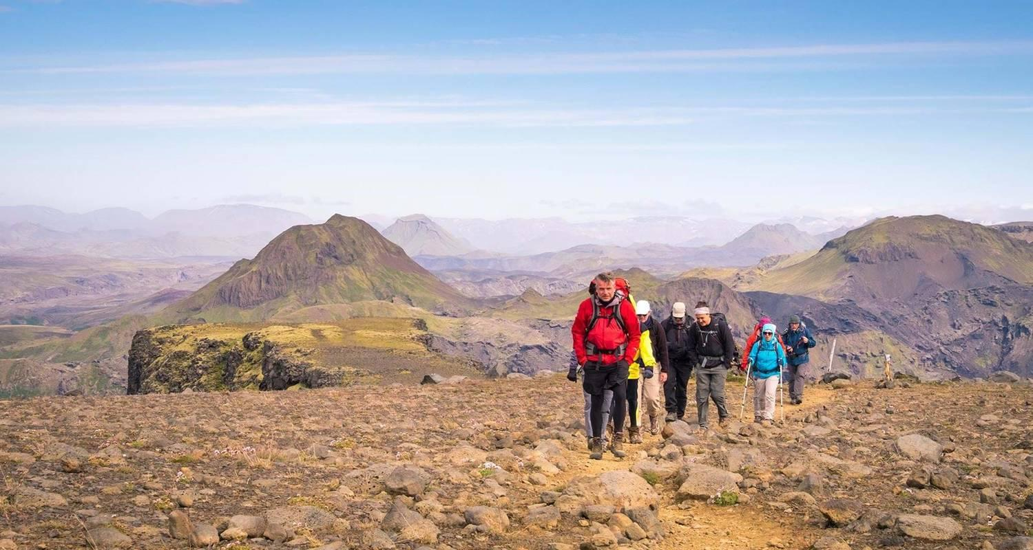

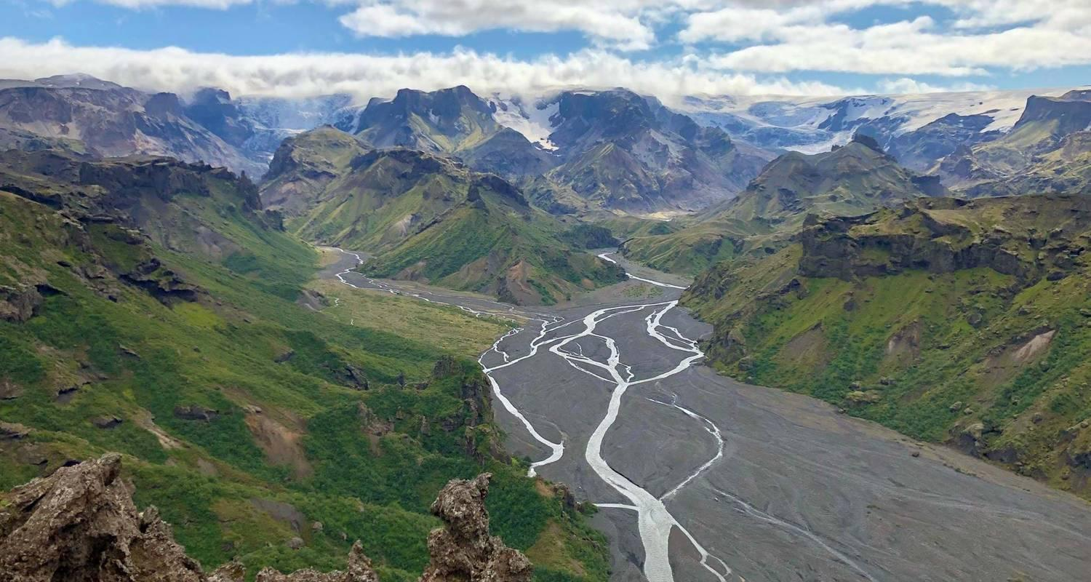

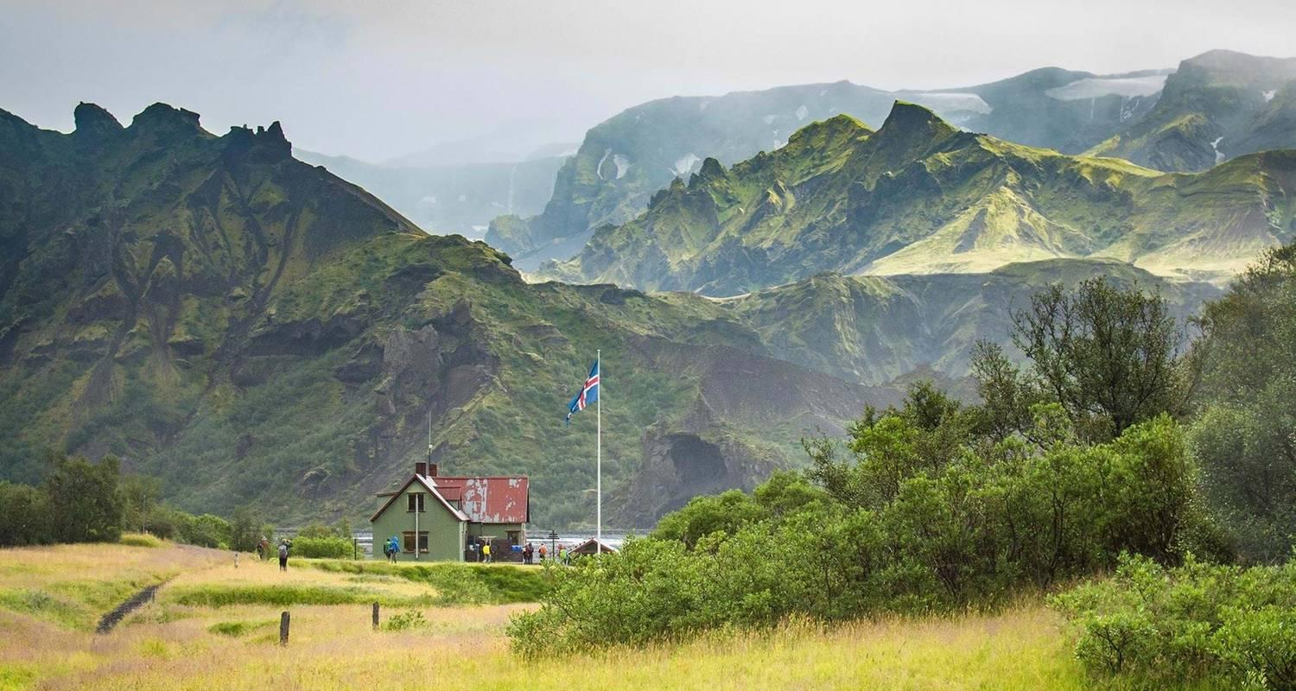

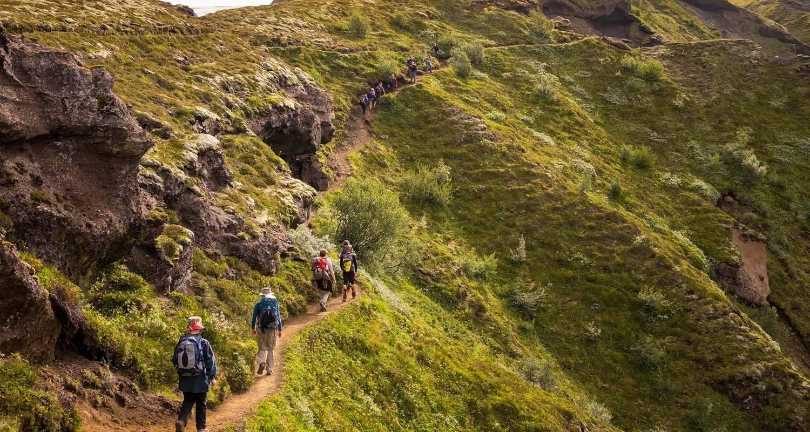

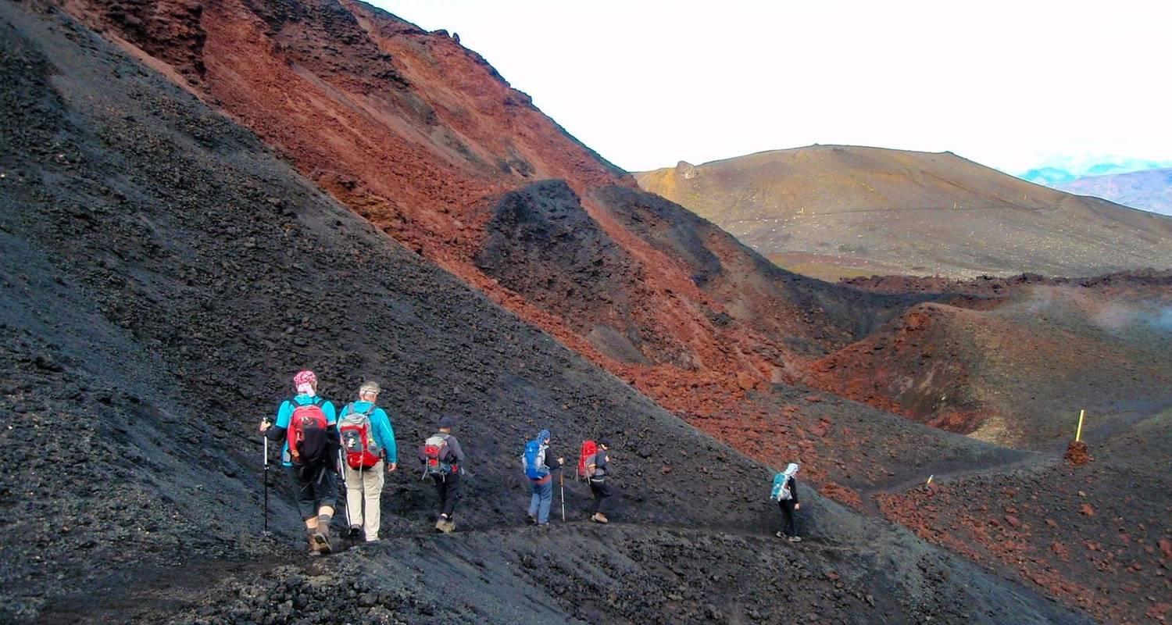

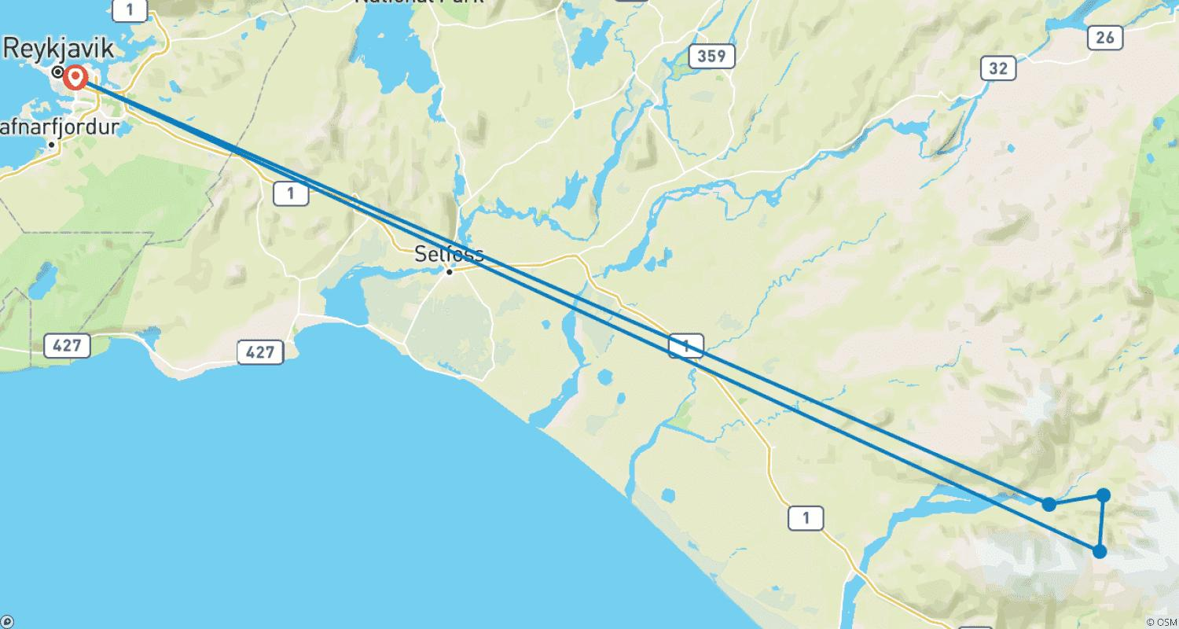

Tour ID: 237640  
Tour Name: Inuit, Icebergs and Northern Lights

Tour destinations: ['Keflavik', 'Tasersuatsiaq', 'Narsaq', 'Uunartoq', 'Tasiusaq', 'Nanortalik', 'Qaqortoq', 'Narsarsuaq']

Tour destinations images:

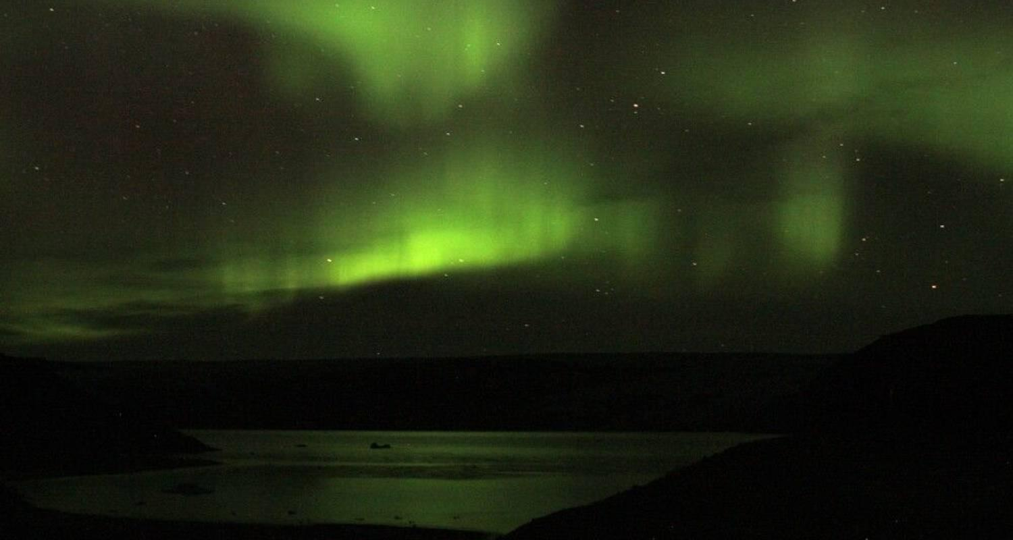

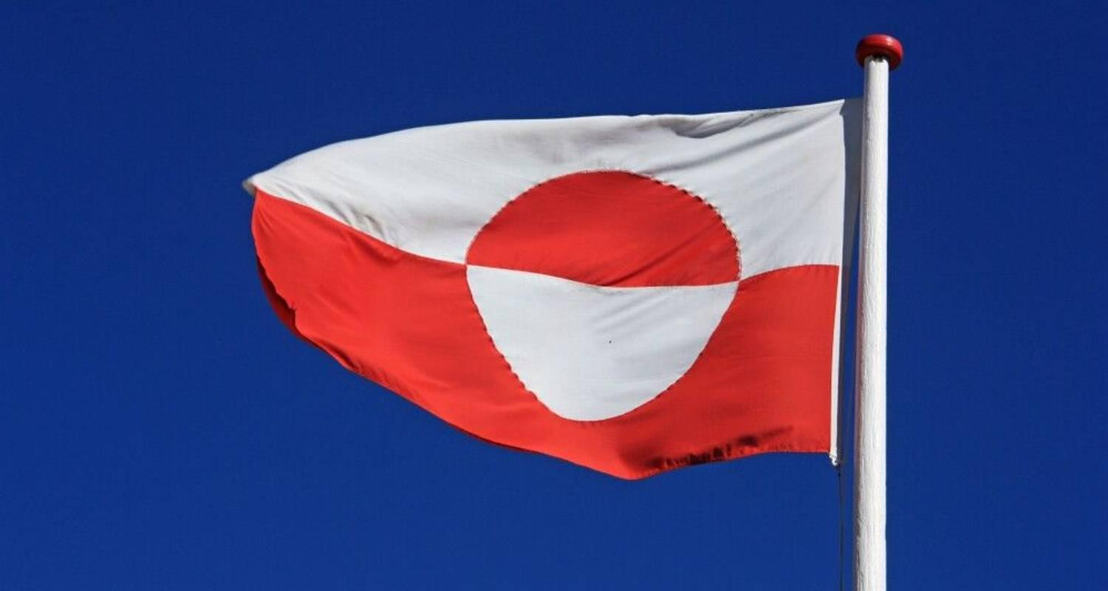

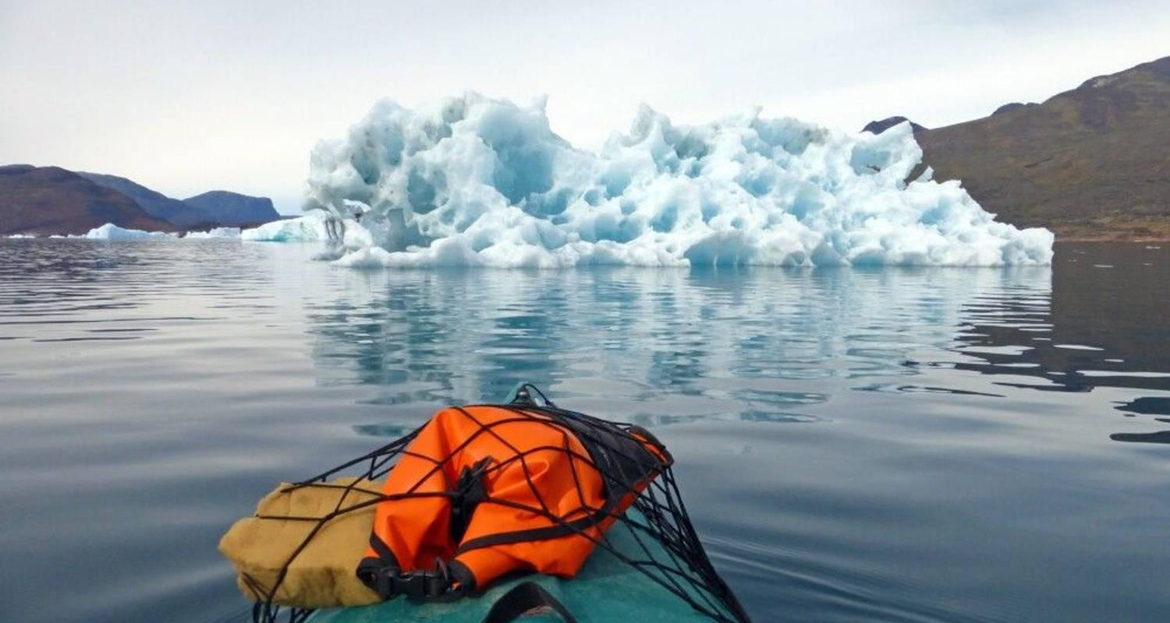

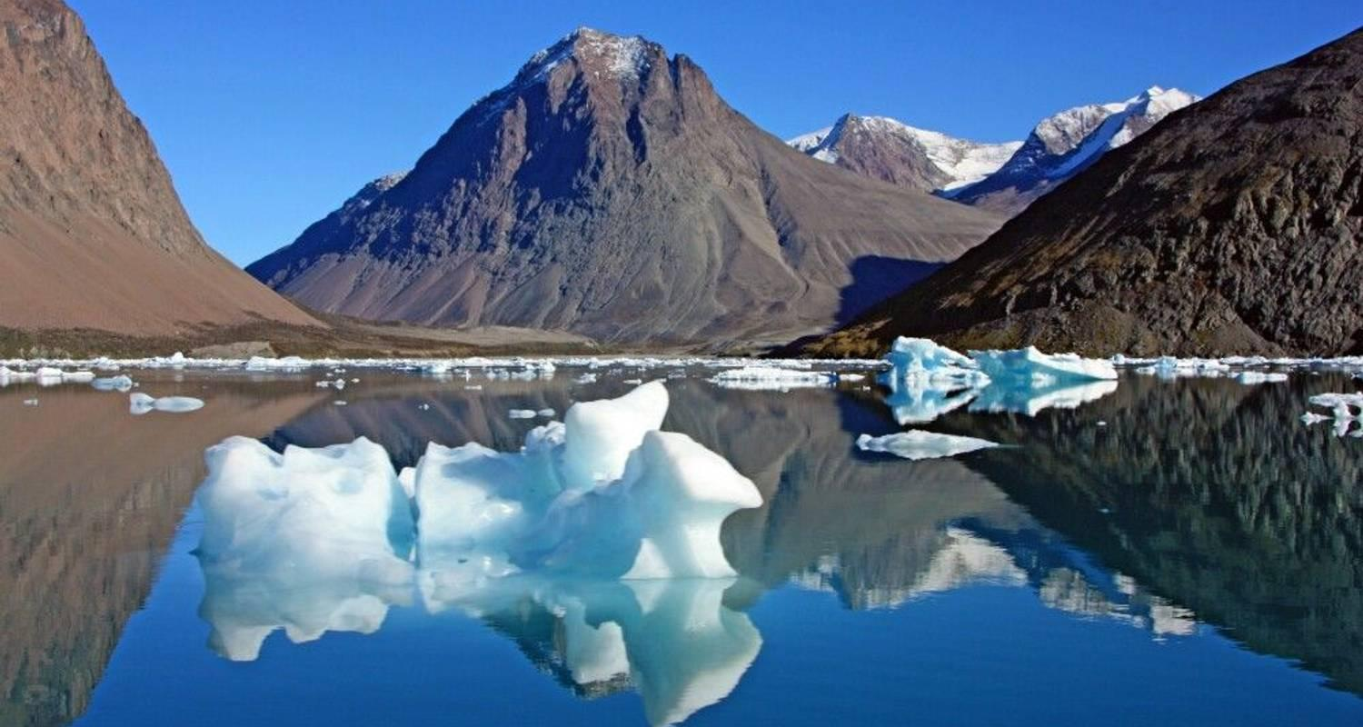

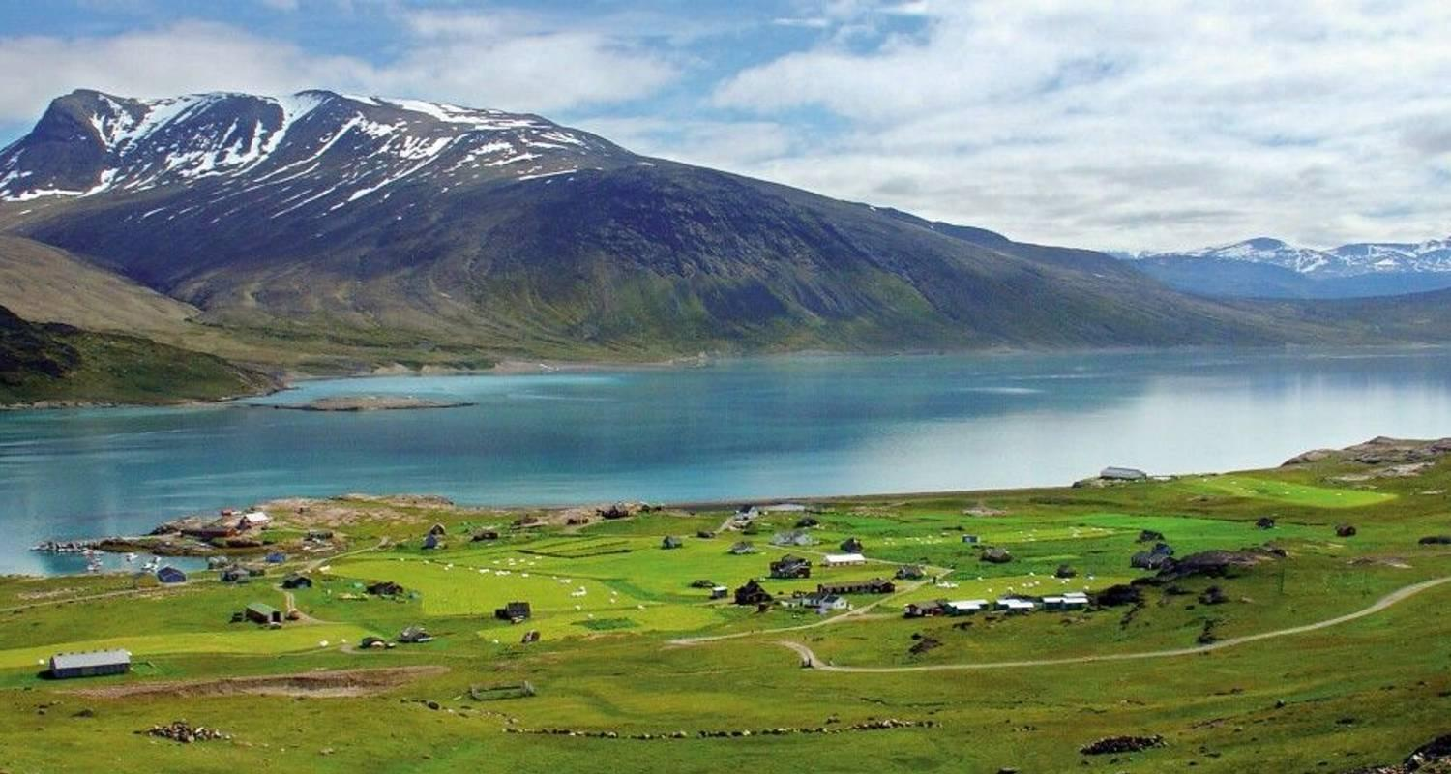

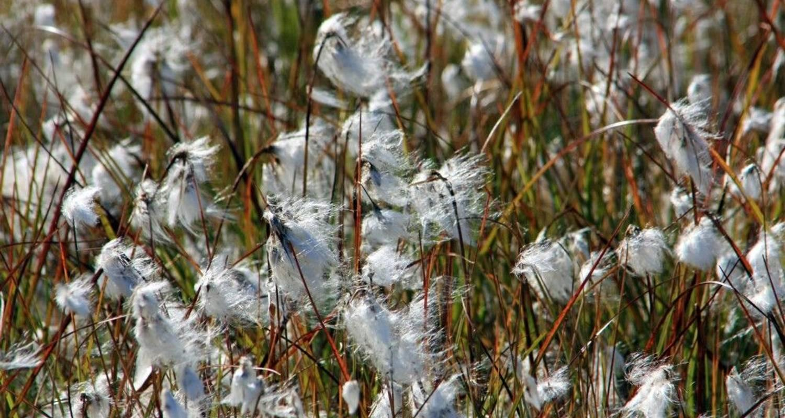

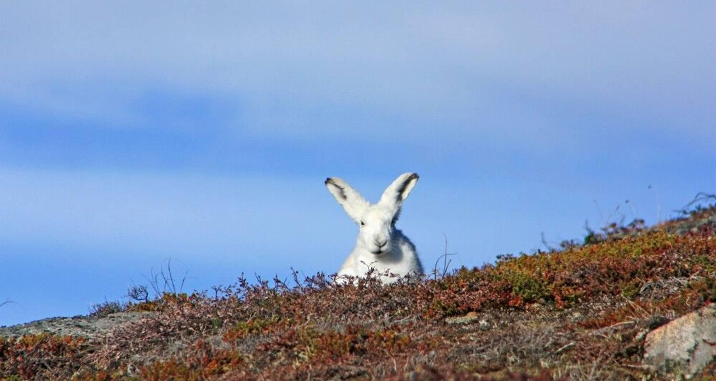

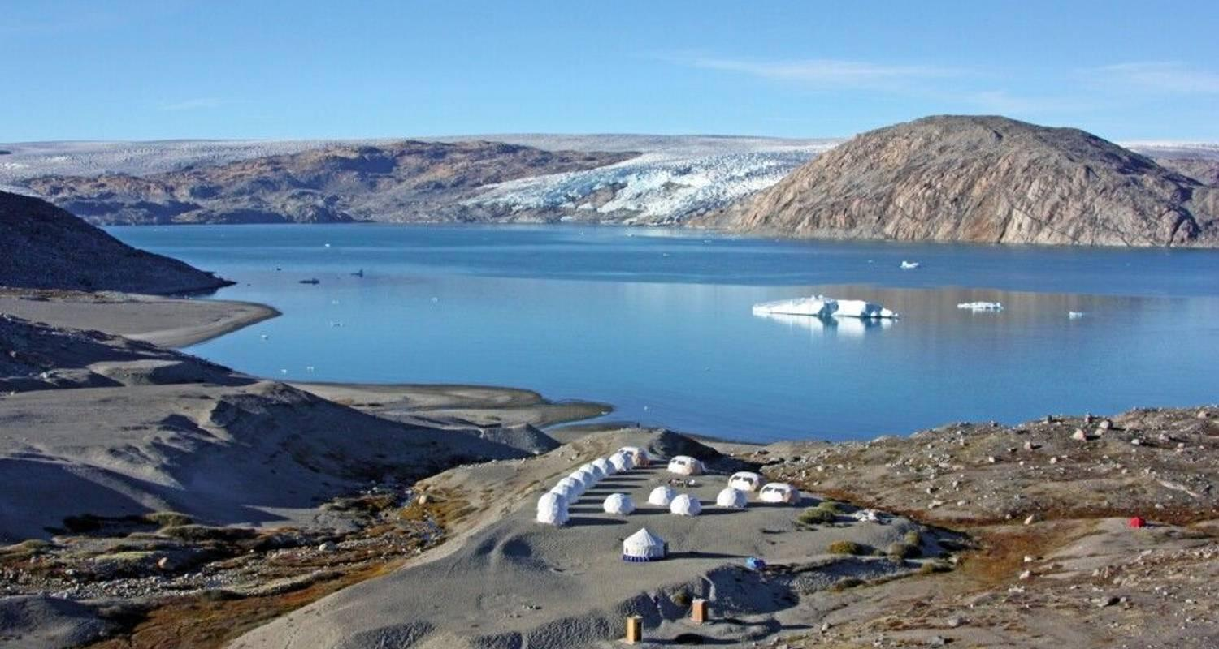

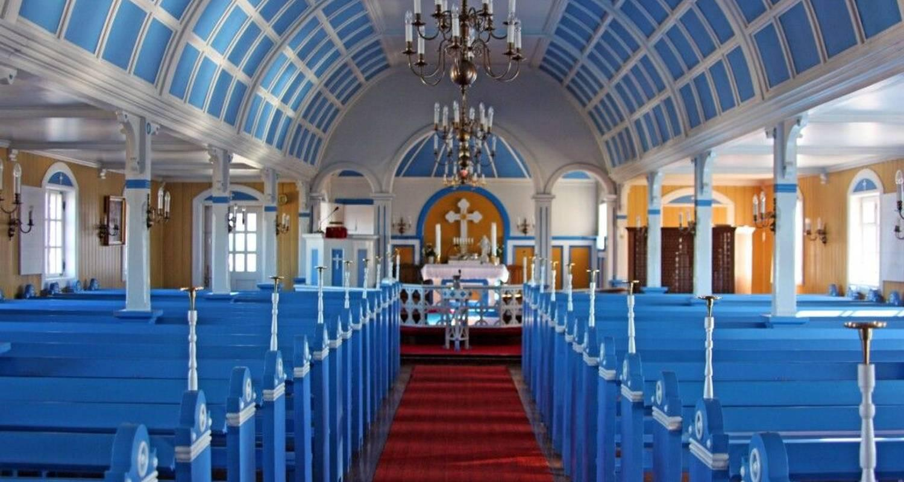

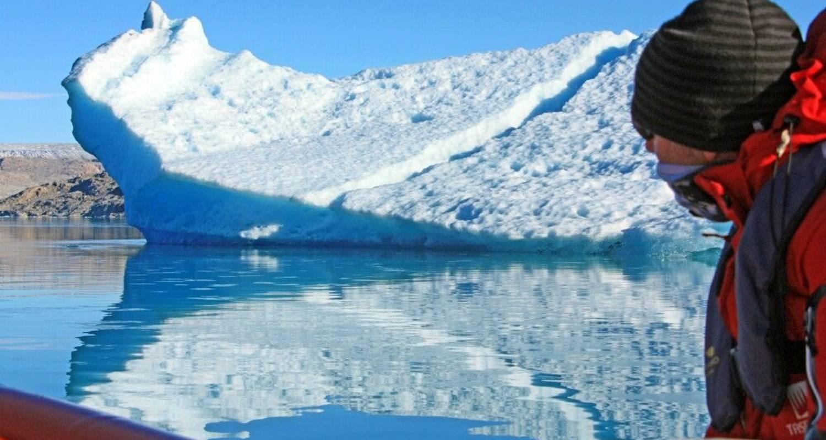

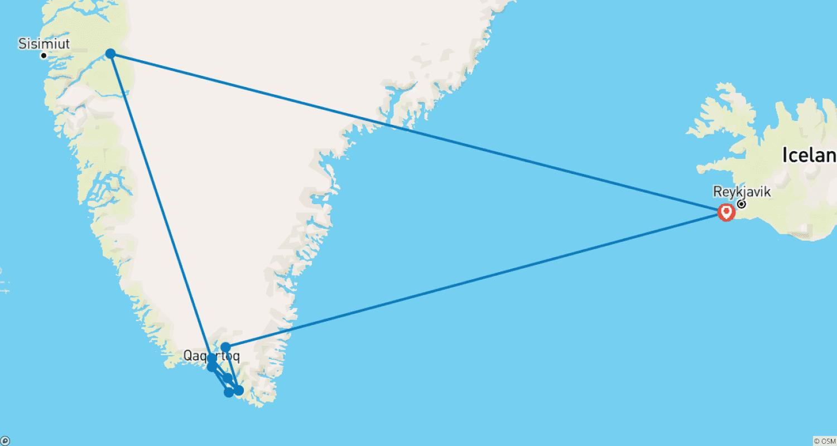

Tour ID: 237664  
Tour Name: Under the Spell of the Elemental Forces

Tour destinations: ['Reykjavik', 'Thingvellir National Park', 'Kerlingarfjöll', 'Dalvik', 'Akureyri', 'Myvatn', 'Askja', 'Dettifoss', 'Bakkagerdi', 'Jokulsarlon', 'Skaftafell', 'Landmannalaugar']

Tour destinations images:

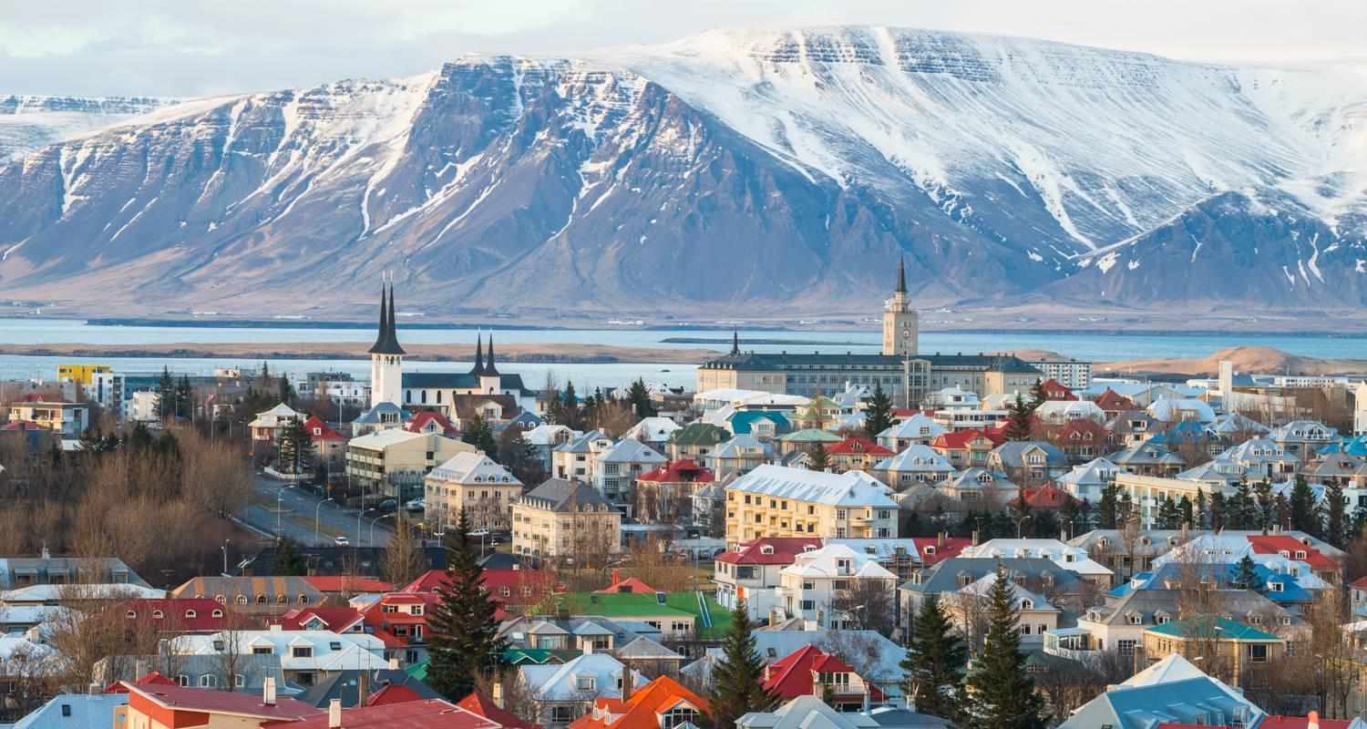

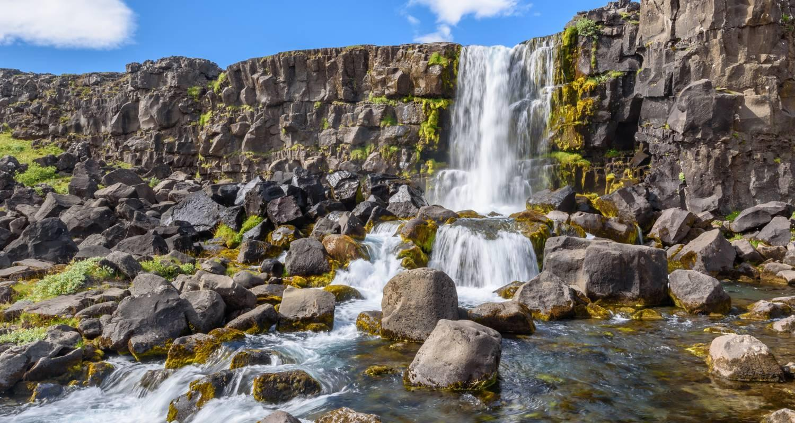

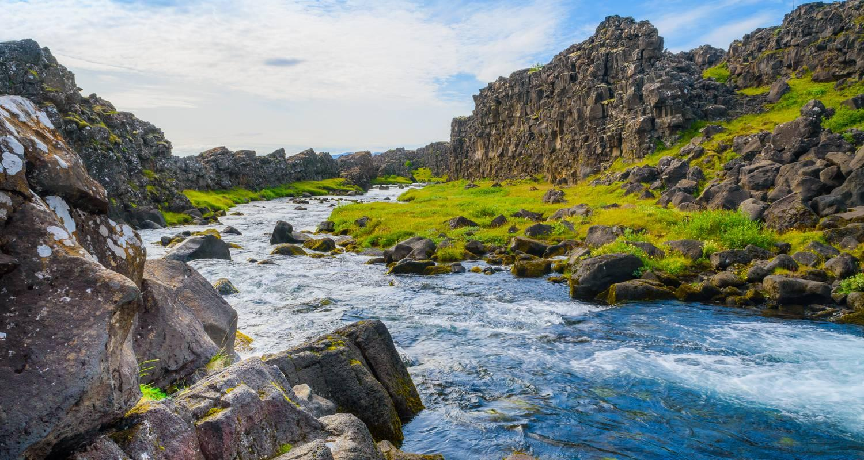

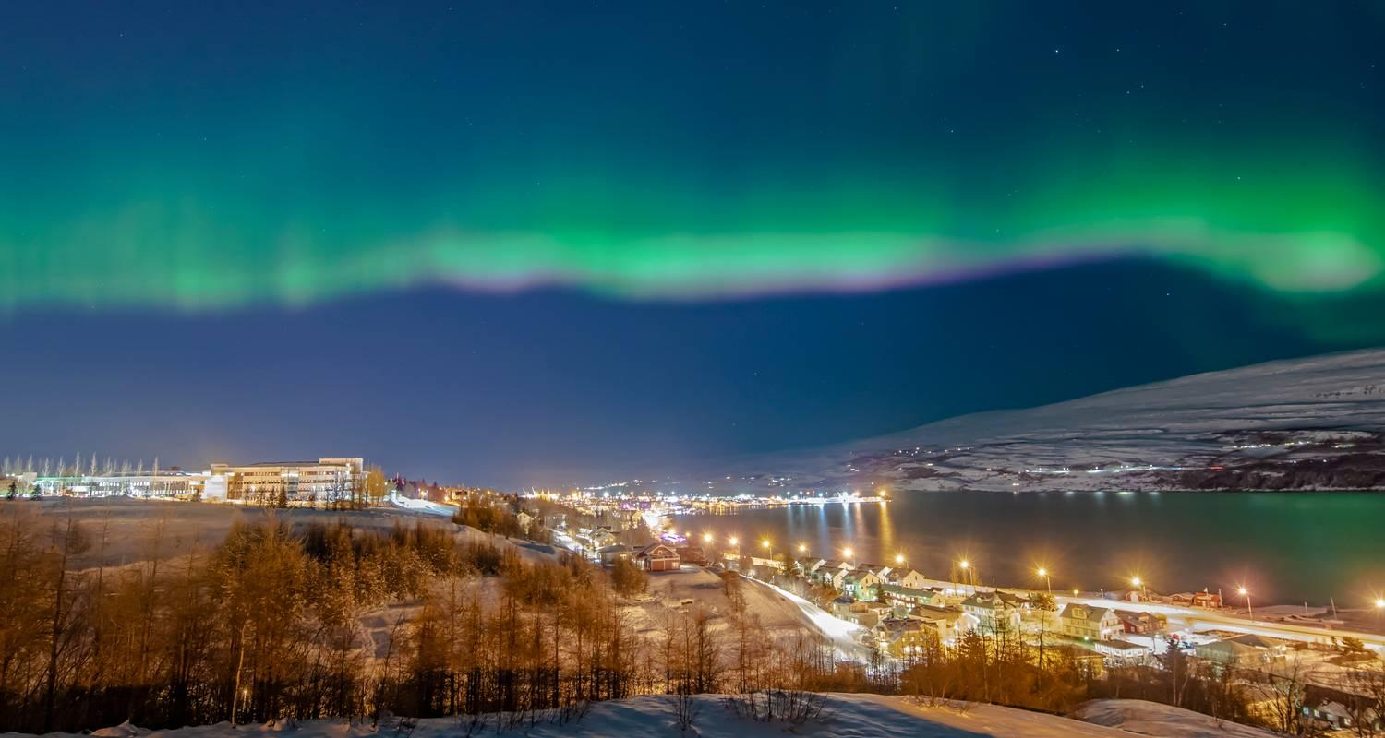

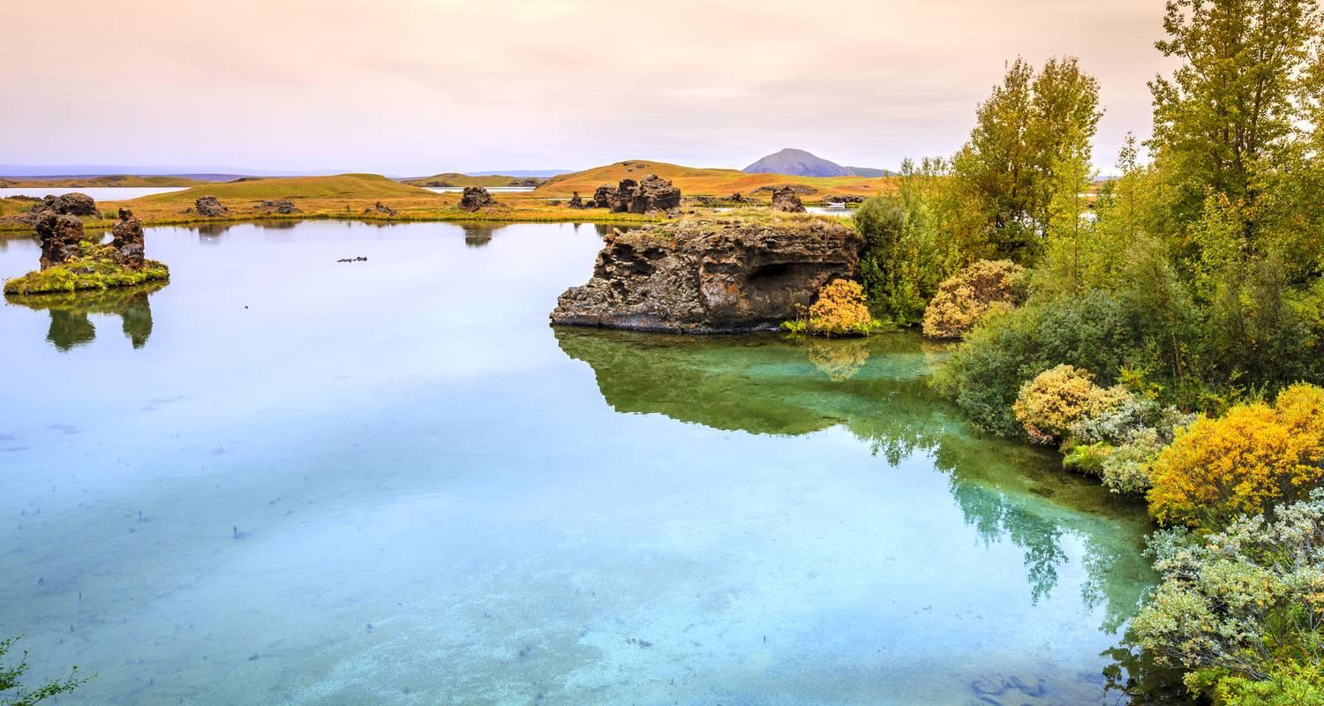

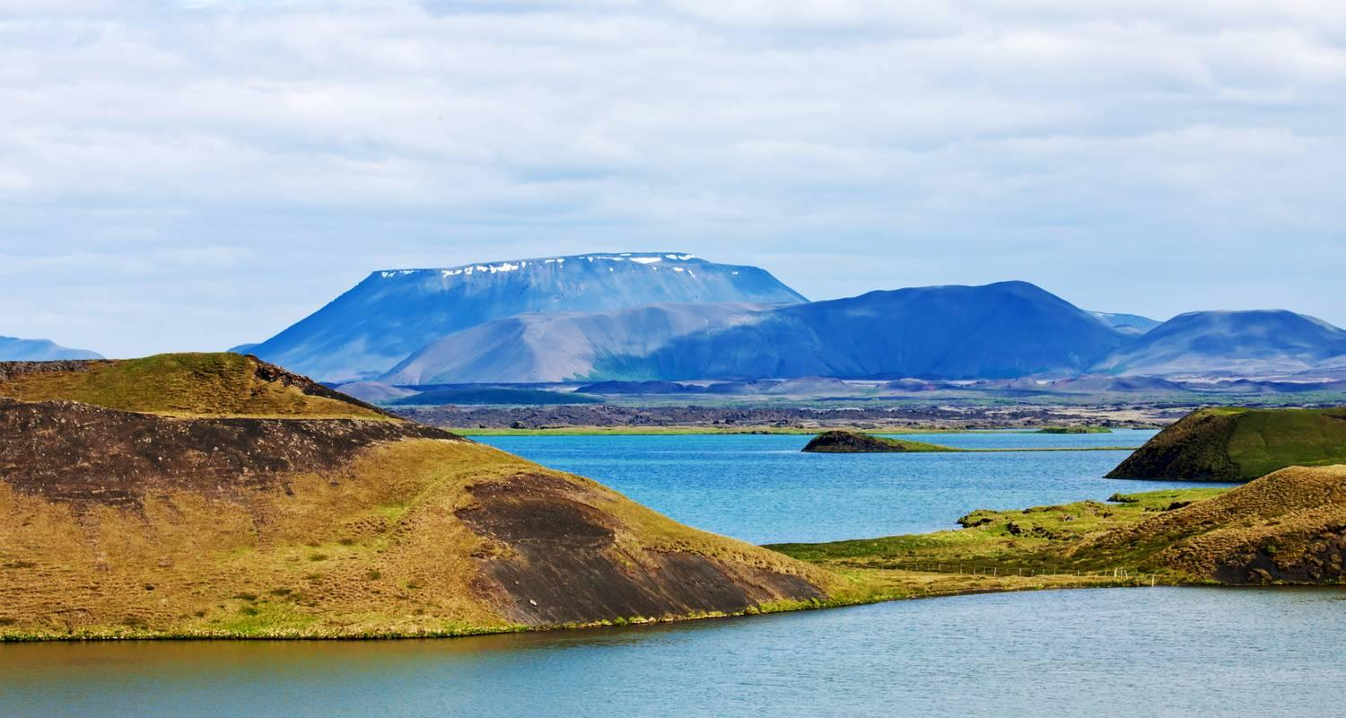

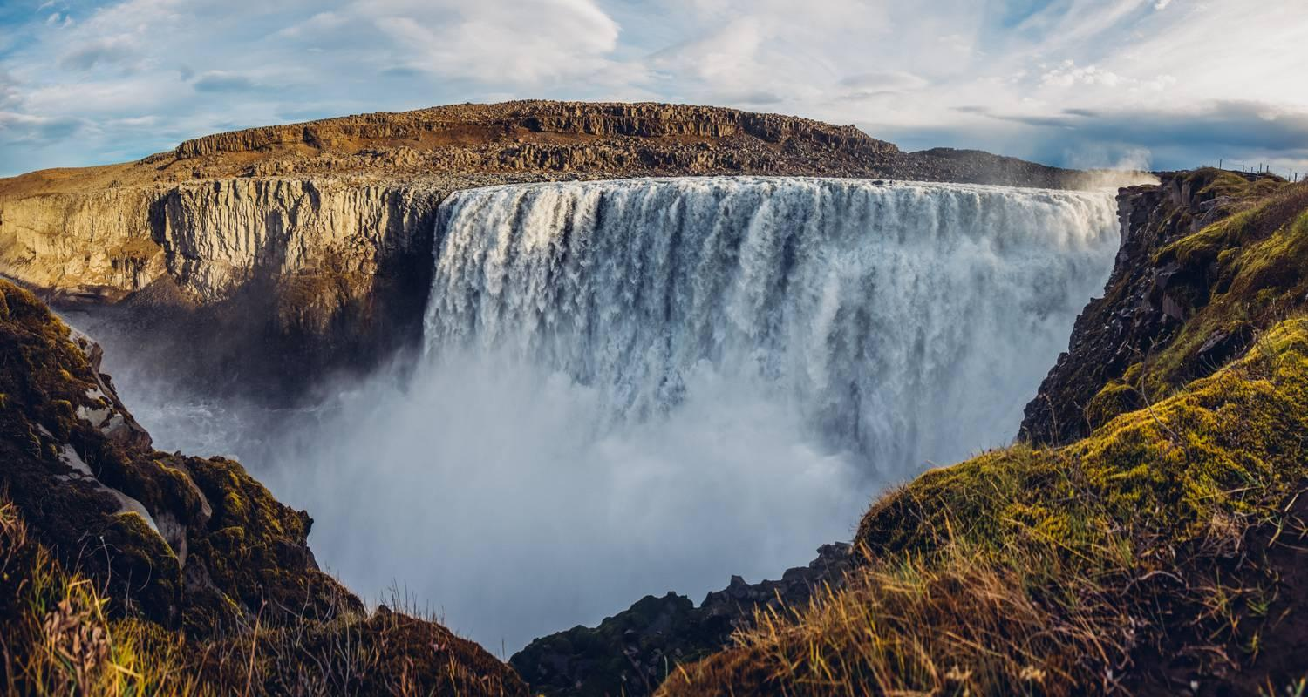

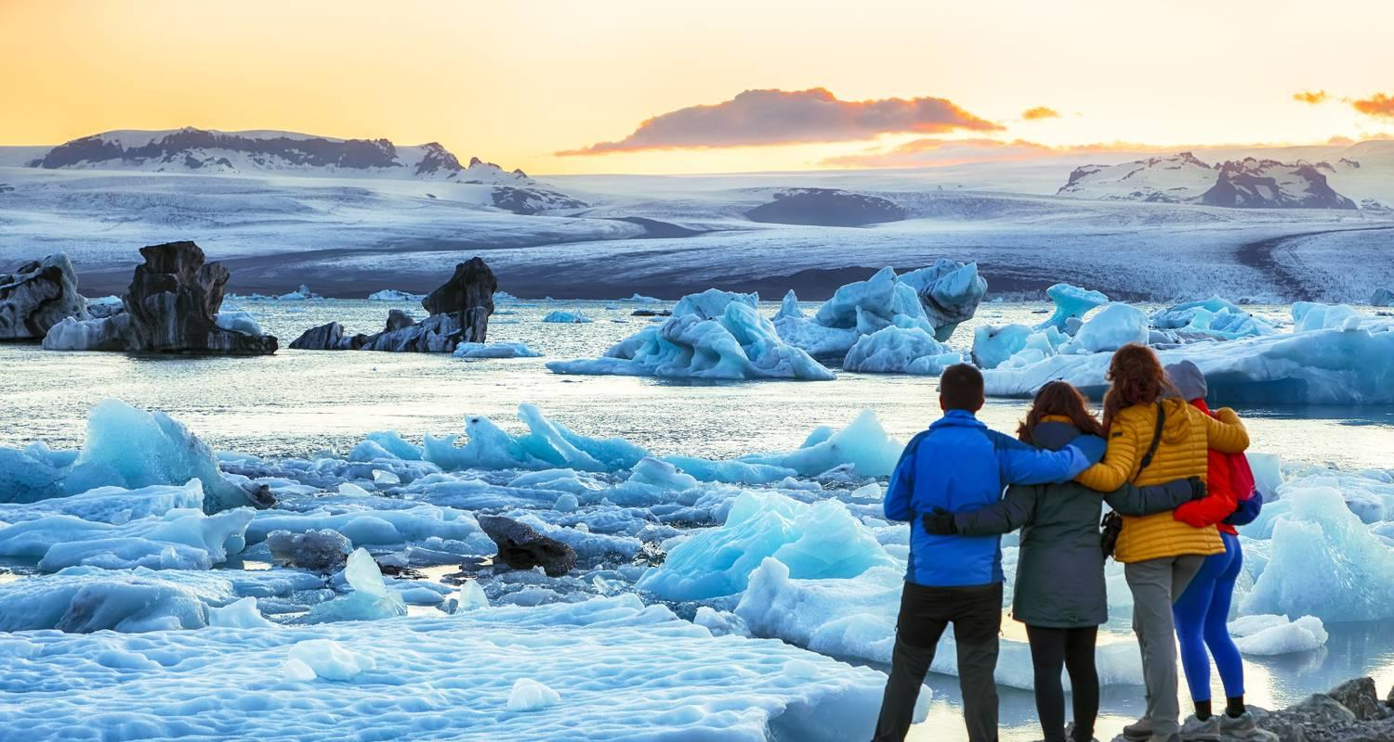

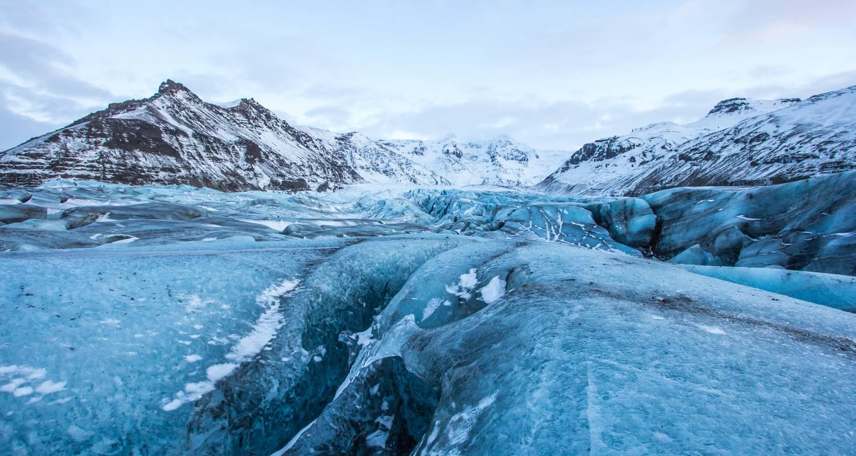

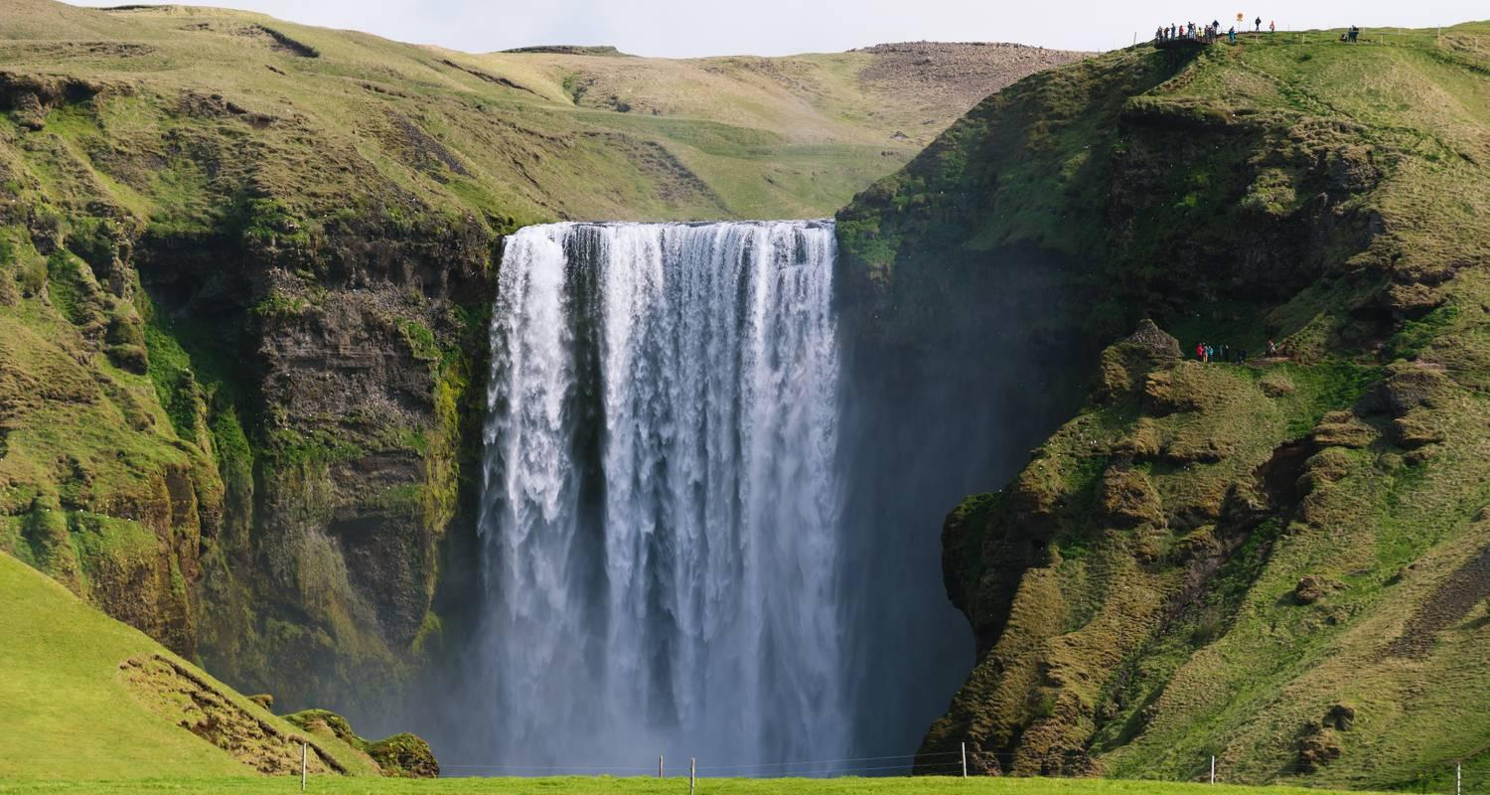

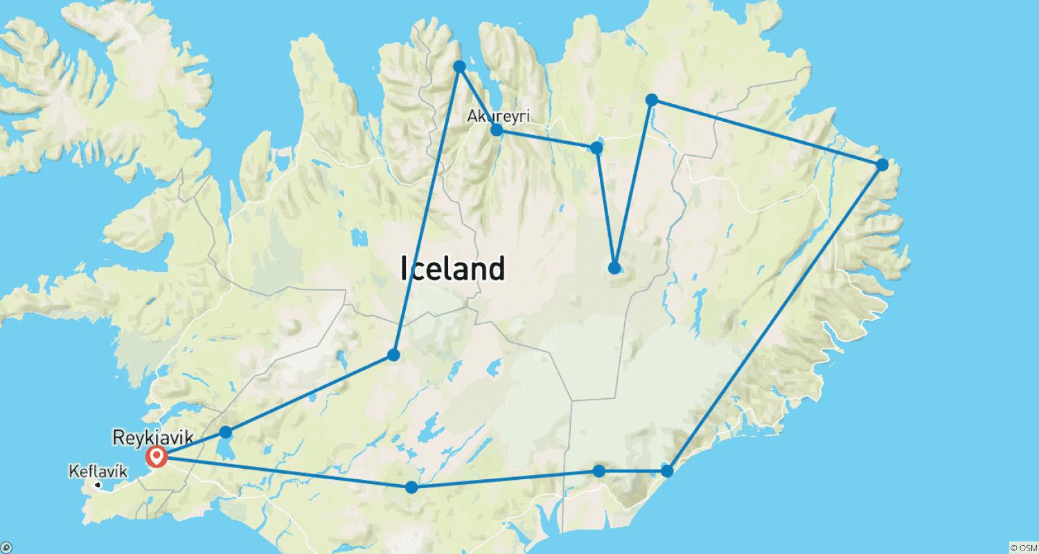

Tour ID: 237703  
Tour Name: Autumn Color Frenzy in the Arctic

Tour destinations: ['Longyearbyen', 'Nordvest-Spitsbergen National Park', 'Northeast Greenland National Park', 'Scoresby Sound', 'Akureyri']

Tour destinations images:

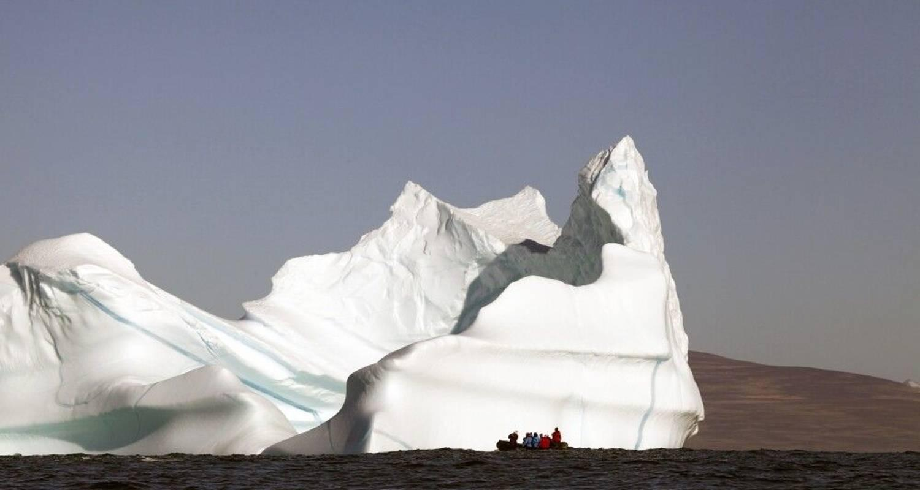

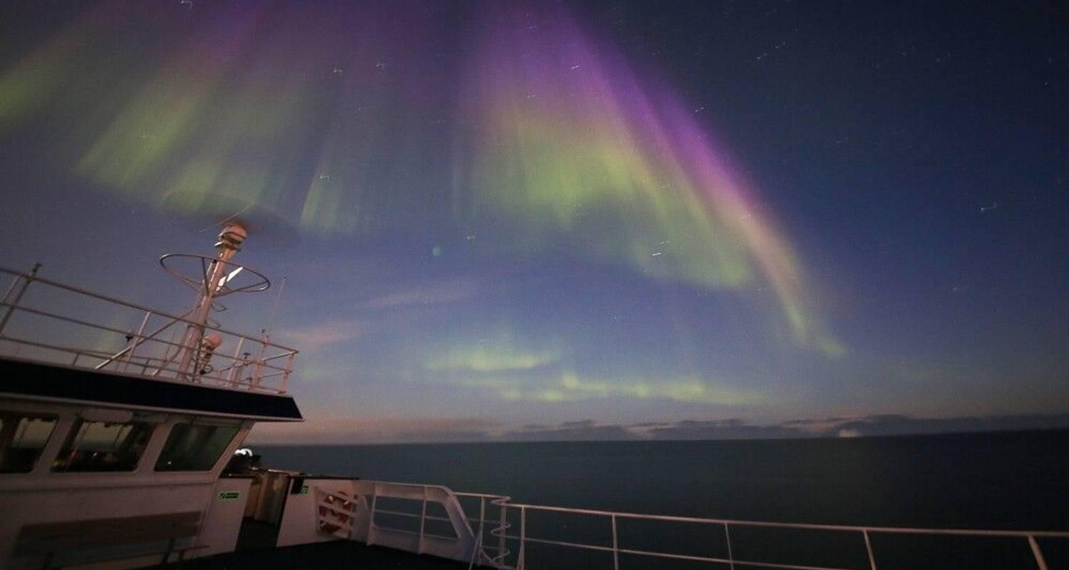

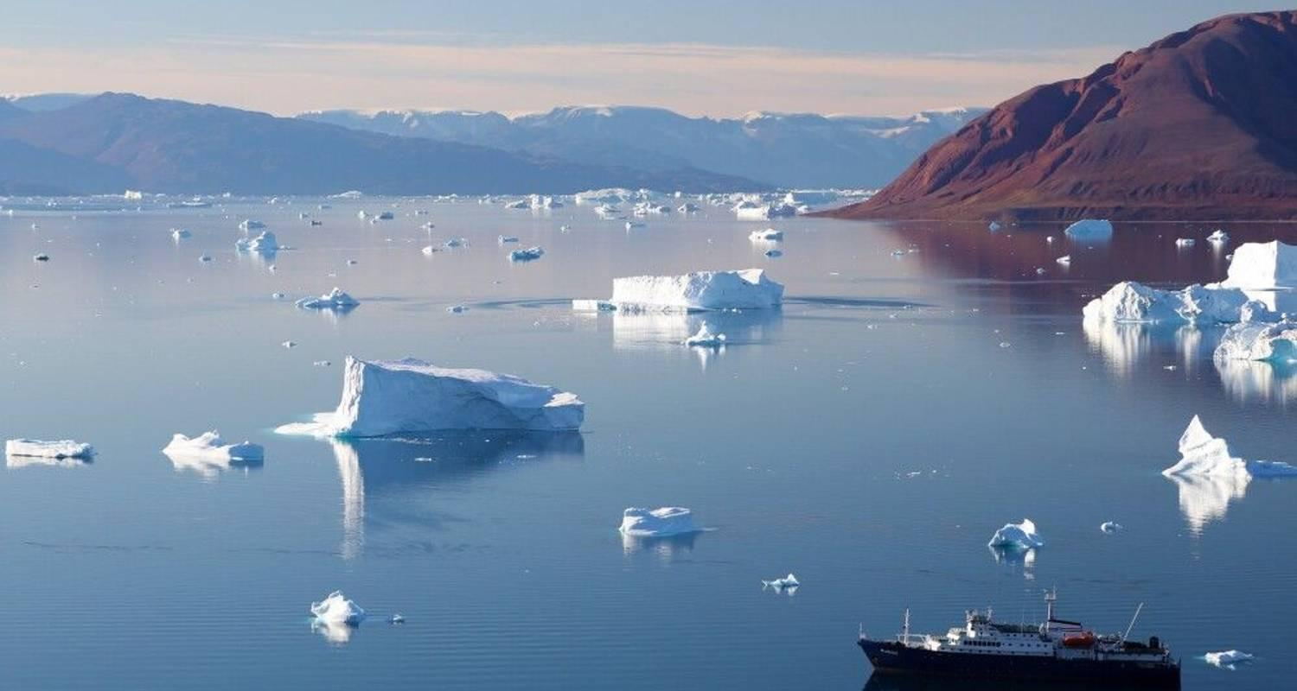

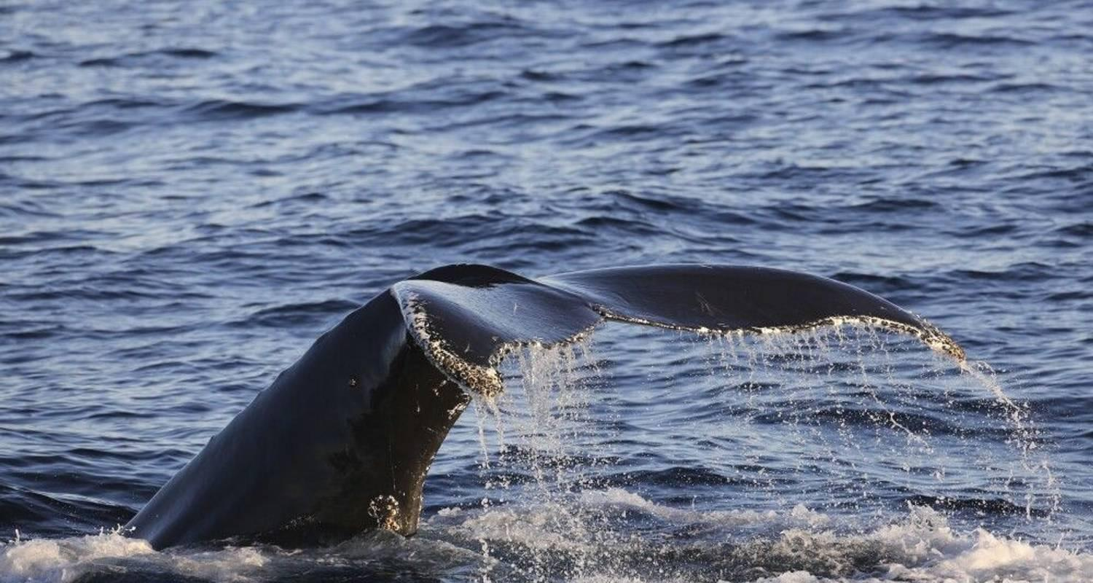

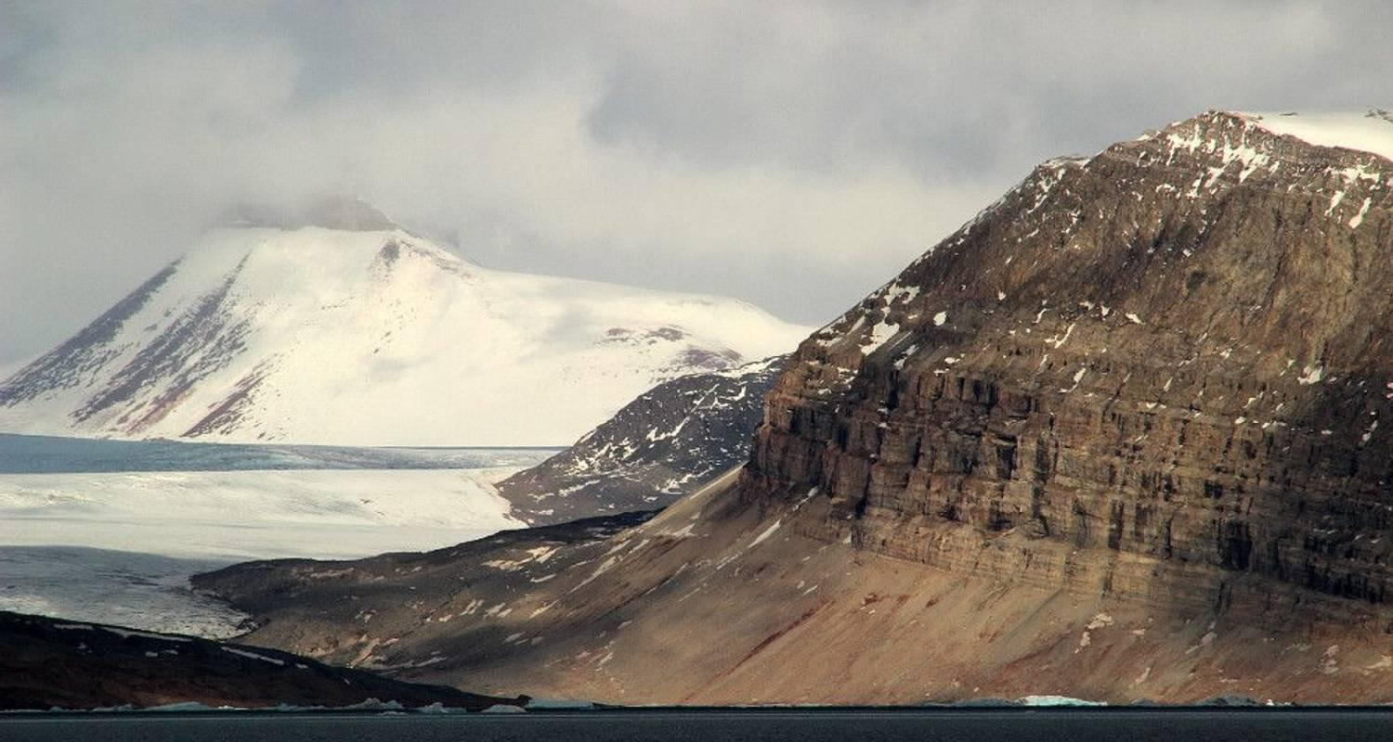

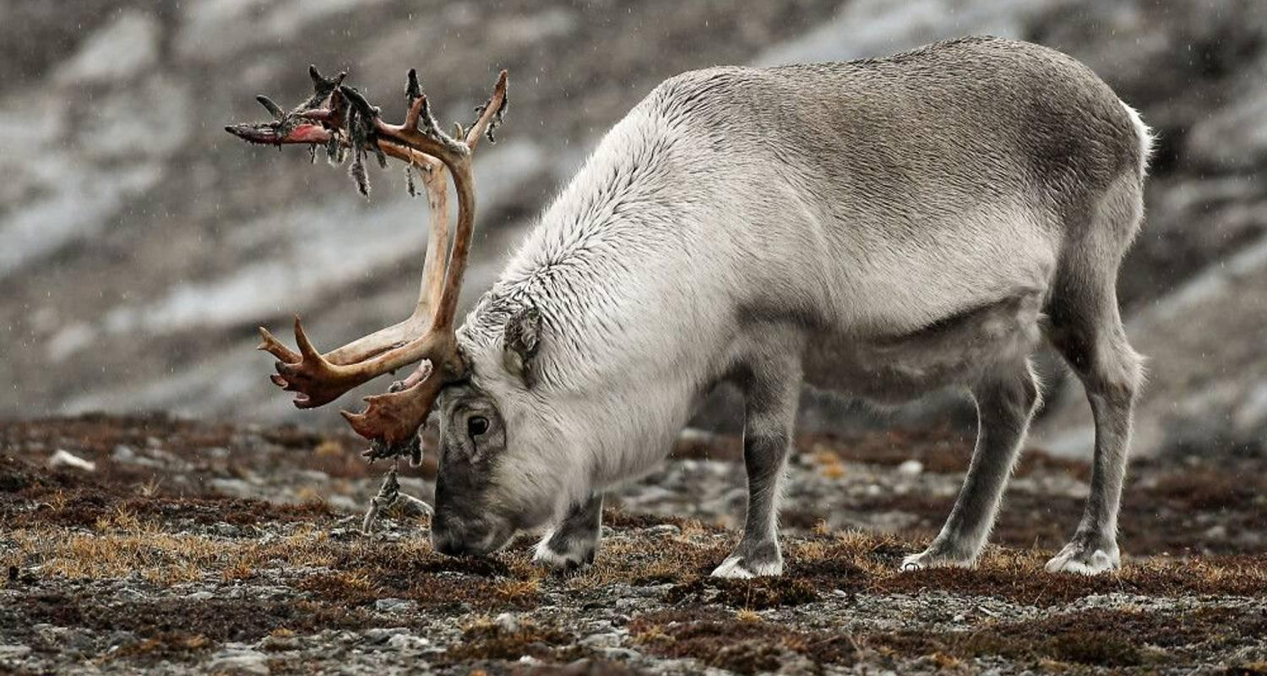

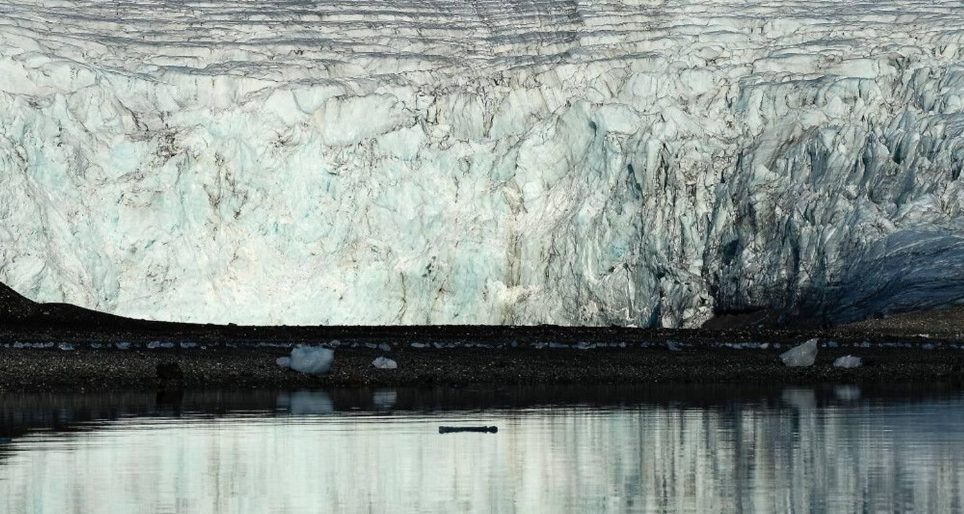

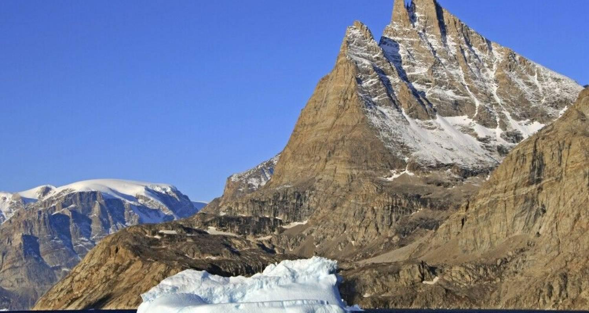

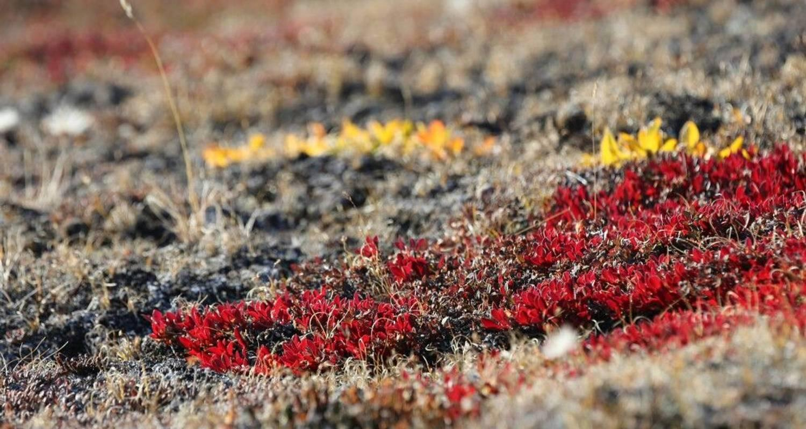

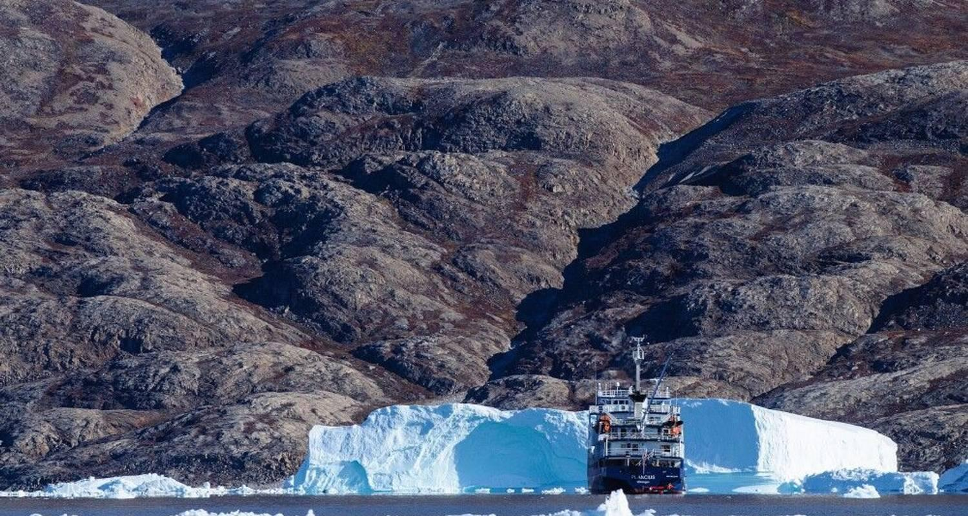

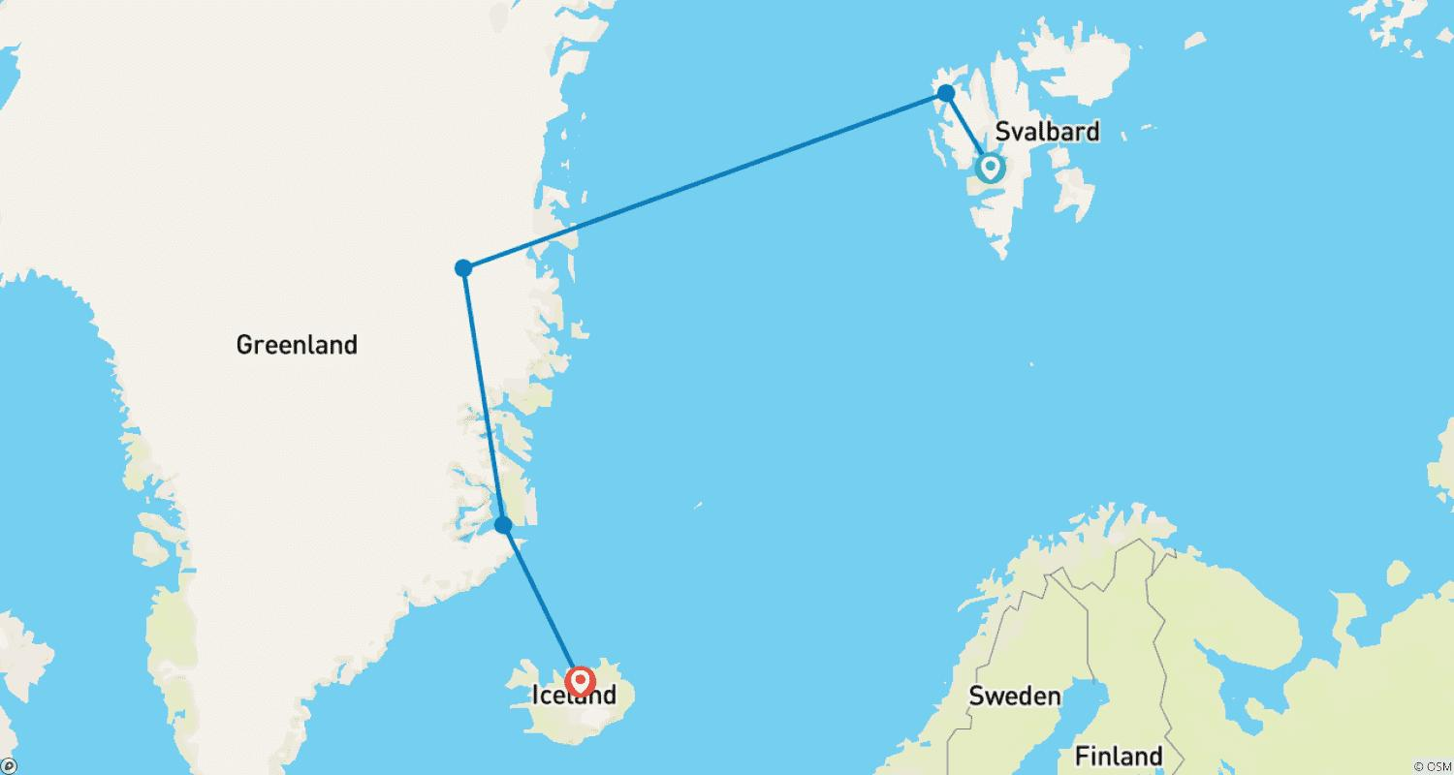

Tour ID: 237704  
Tour Name: Around the Island of Fire and Ice

Tour destinations: ['Reykjavik', 'Thingvellir National Park', 'Geysir', 'Gullfoss', 'Landmannalaugar', 'Skogafoss', 'Vik', 'Skaftafell', 'Svartifoss', 'Jokulsarlon', 'Hofn', 'Djupivogur', 'Myvatn', 'Mount Namaskard', 'Dettifoss', 'Husavik', 'Dalvik', 'Saudarkrokur', 'Blonduos', 'Snæfellsnes', 'Kirkjufell Mountain', 'Hellnar', 'Borgarnes']

Tour destinations images:

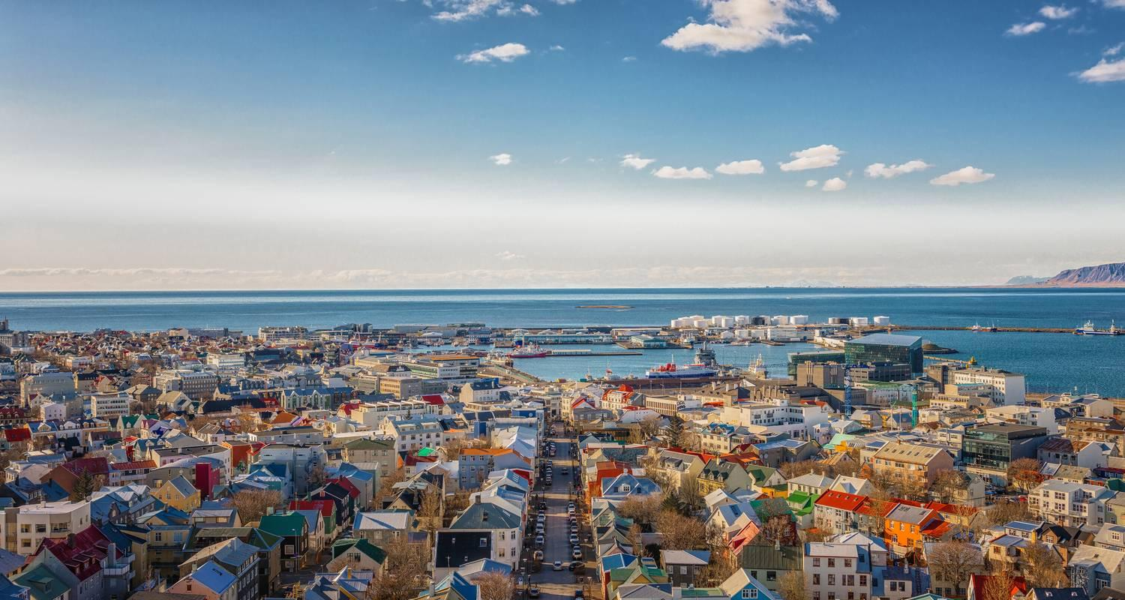

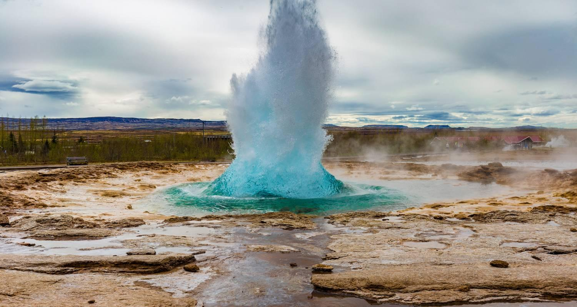

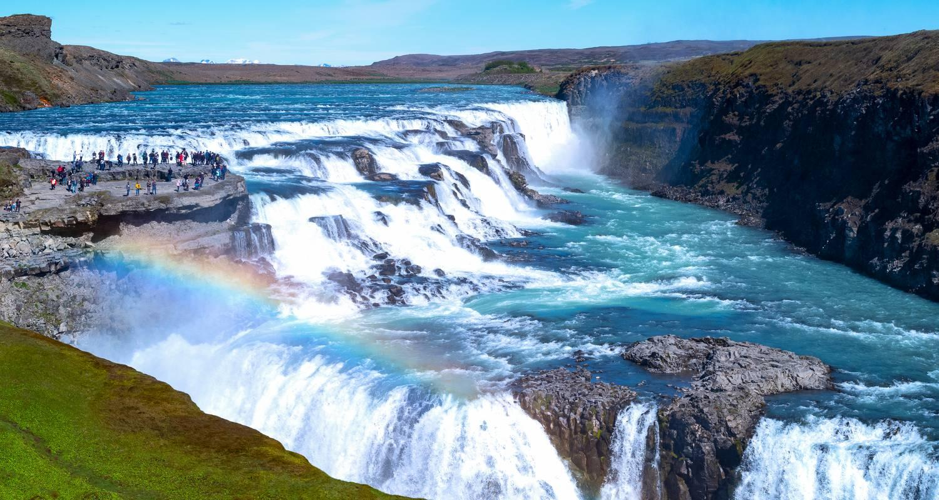

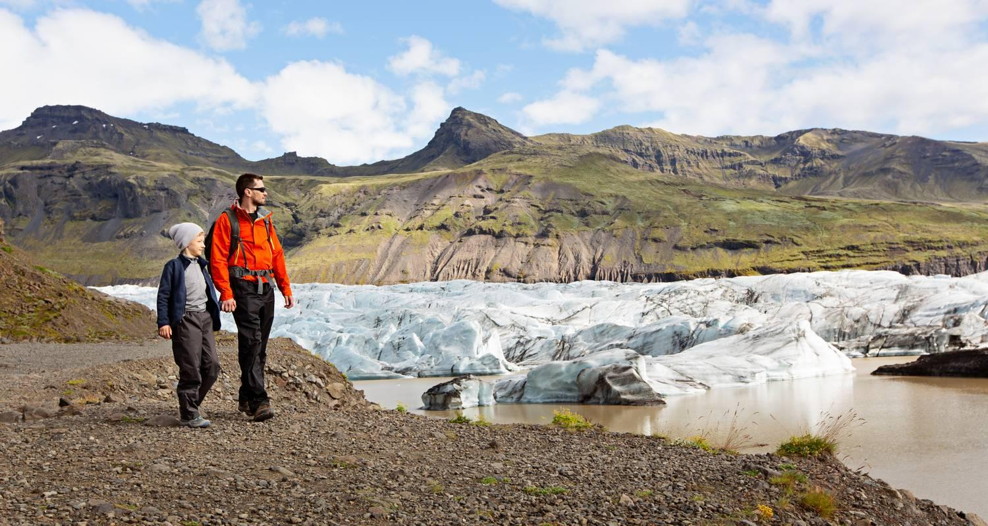



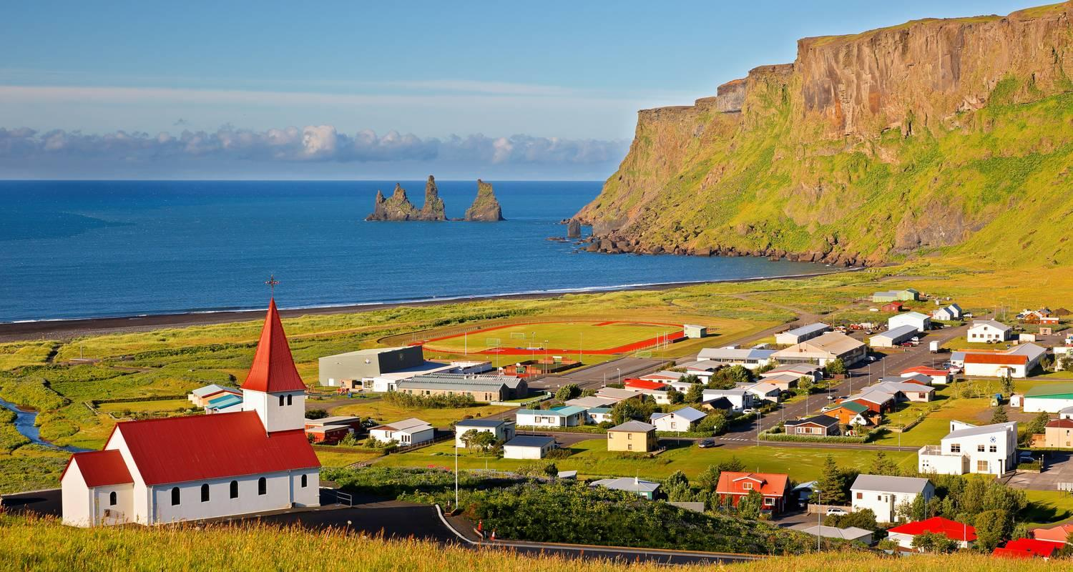



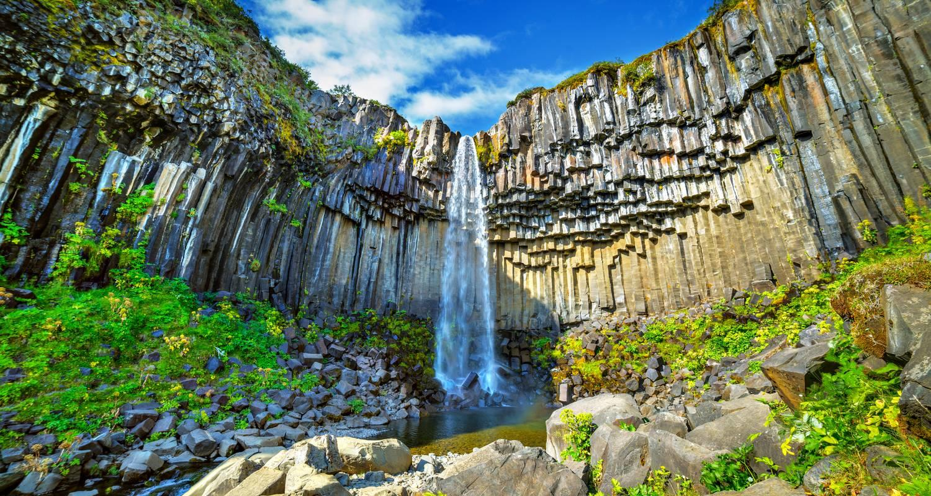

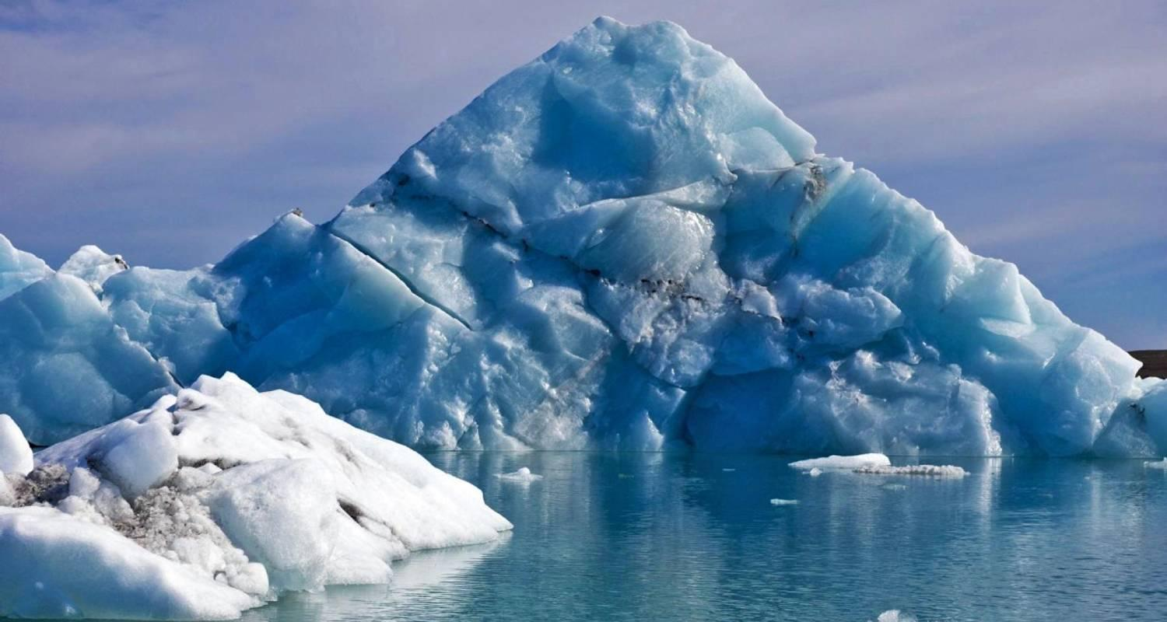

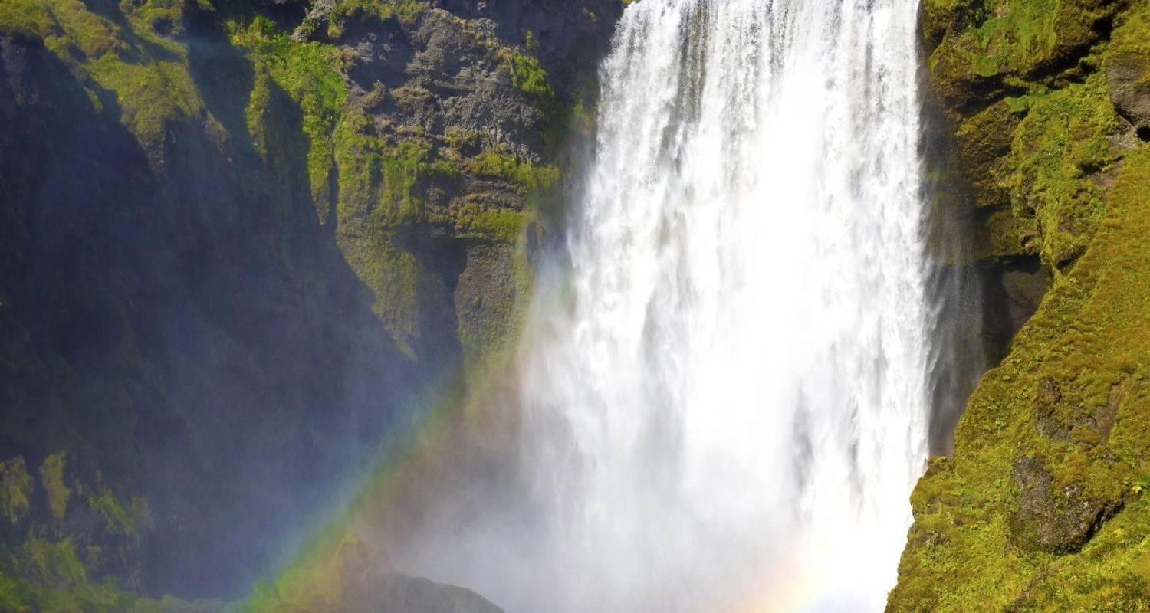

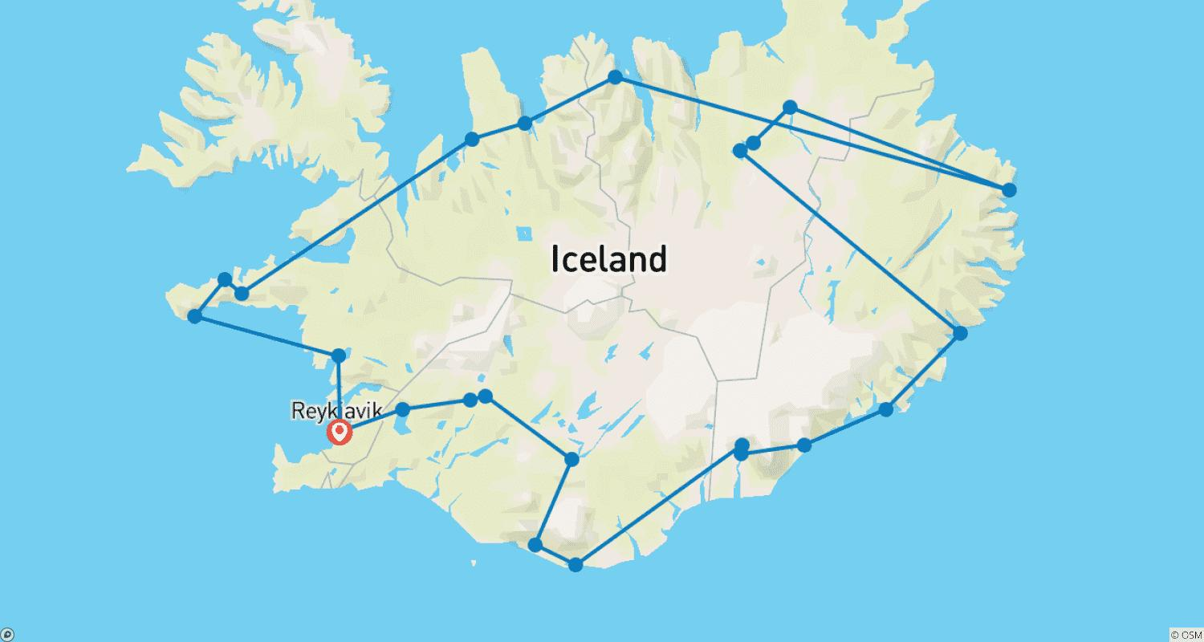

Tour ID: 237708  
Tour Name: Fire, Earth, Ice and Water

Tour destinations: ['Keflavik', 'Reykjavik', 'Thingvellir National Park', 'Gullfoss', 'Fludir', 'Hekla Volcano', 'Seljaland', 'Skogar', 'Vik', 'Skaftafell', 'Jokulsarlon', 'Reynisfjara', 'Reykjanesviti']

Tour destinations images:

